Java Technologies
J2SE
J2EE
J2ME

J2SE: J2SE stands for Java2 standard Edition. Used to develop client applications

J2EE: J2EE stands for Java2 Enterprise Edition. Used to develop server applications.

J2ME: J2ME stands for Java2 Micro Edition. Used to develop mobile applications.

History of Java: In the 1991 a language called OAK was developed by James Gosling & Patrick Naughton with some other programmers at Sun Microsystems, U.S.A. OAK was developed to program Home appliances like TV, Washing Machines, Refrigerators etc. Later on 23rd January 1996 a programming language named as JAVA was introduced.It is targeted to main stream systems.

Features of Java:

- Java is simple because it derive its syntaxes from C and OOPs concepts from C++, Smalltalk, Ada. No pointers concept and complicated concepts like multiple inheritance thru classes. These are implemented differently.
- Portable: It is 100% portable language. Portability is due to Byte code. Java’s slogan is write once and execute any where.

Java
Source Code

compiler

Byte Code

Windows

PIV
VSAM

M/F
OS/9

MAC

JVM for JVM for JVM for
Windows Main Frame Machitosh

**What is the difference between .exe file and a .class file?
--------------------
Ans:
------
**.Exe file contains machine language instructions understandable by micro processor.
.class file contains byte code instructions understandable by the JVM(JAVA VIRTUAL MACHINE).

.Exe file is System dependent.
.Class file is System Independent.
**JVM is system dependent.

MAJOR SECURITY PROBLEMS FOR DATA ON INTERNET:
----------------------------------------------------------------------------------

1.EAVESDROPPING:
-----------------------------
Reading others data illegally is called Eavesdropping.This is the major problem.

2.Tampering:
------------------
Not only reading others data but also modifying is called Tampering.

3.Impersonation:
-----------------------
A person acting as another person on internet is called Impersonation.

4.Virus:
------------
Virus is a harmful program that can damage data,s/w, and h/w of a computer system.

- Robust: Java programs can run on all types of environments because
  - It is strictly typed language
  - It can manage memory thru Automatic garbage collector.
  - It can handle run-time errors thru exception handling.

- Secured: Java programs are highly secured because of JVM – interpretation and the programs runs in JRE-Java Runtime Environment, a virtual environment that guards and encapsulates the running program. If the program violates java rules it will be shutdown.
- Multithreaded: Java has in built multithread capability. In multithreading environment multiple subprograms execute concurrently.
- Distributed: Java allows you writing distributed programs i.e. a distributed program can communicate and execute programs stored on different machines. These programs can intercommunicate with one another and it is called RMI (Remote Method Invocation) in Java.
- Networked: Java programs support all types of network protocols and also Java provides so many in built classes, methods and interfaces to develop high efficient network programs.
- Interpreted & High performance: since java interprets byte code which is a complied version. It does not take much time to translate as happens in purely interpreted languages.

EX:- BASIC

But compared to compiled languages it is slower. To boost the performance you can JIT (Java In Time Translator).

Programming Methodologies

PROCEDURAL
PROGRAMMING
EVENT DRIVEN
PROGRAMMING
OBJECT ORIENTED
PROGRAMMING

OOPs Conecpts:
1.Encapsulation(Binding): Binding the related data members(variables) and member functions(methods) in to a single entity is called Encapsulation. Classes use Encapsulation concept.

2.Abstraction(Hiding): Abstraction allows hiding unwanted details from external programming. In oops a clearly designed program can reveal only such data that is required by external world. Here we create objects that communicated with each other by passing messages.
3.Polymorphism(Multiple behavior): In oops an object can behave differently for each type of parameters passed it responds accordingly depends upon the parameters or the context. This is called polymorphism.
4.Inheritance: Inheritance is process where one class acquires the data members and member functions of another class. Inheritance lets you add new modifications to the software without actually modifying the software.
5.Class: The fundamental unit of java programming is class. A class serves as blue print and provides the architecture of an object. Class is logical entity. Objects are created from class. These objects are physical and exist in the memory. All objects are instantiated from a class share similar features. The objects communicates with each other through interfaces (public methods). Any no.of objects can be created from a single class. The class provides encapsulation and abstraction

Character set of Java:
Alphabets – a to z and A to Z
Digits – 0 to 9
Special Characters- +,-,*,/,%,(,),>,<,=,!,| etc

Reserved words: Reserved word is a word that has a predefined meaning in the complier. We should not use these reserved words for other purpose except for which it is designed. There are 49 reserved words in J2SD1.4 version.

Ex:- public, private, protected, for, while etc.

Variable: The value of the object, which changes during the execution of the program, is referred as a variable. Sytax to declare a variable in Java as follows:
<Datatype> <variable>[=<value>];

Constant or Literal: The value of the object, does not which changes during the execution of the program, is referred as a constant. The following are the different type of constants available in java.
1. Integer constants. 2. Float constants. 3. Double constants.
4. Character constants. 5. String constants.
Data Types: There are 9 primitive data types in Java. They are:

Data type width(in bytes) Range
------------ ------------------ --------

byte 1 (or) 8 bits -128 to +127

short 2 (or) 16 bits -32768 to +32767

int 4 (or) 32 bits -2147483648 to +2147483647

long 8 (or) 64 bits -9223372036854775808 to
+9223372026854775807

float 4 (or) 32 bits 1.4e-045 to 3.4e+038

double 8 (or) 64 bits 4.9e-324 to 1.8e+308

char 2 (or) 16 bits 0 to 65535

boolean ------ true/false

void ------ -----

Operators: The follwing are the different categories of operators available.

1. Arithmetic operators: These operators are use to perform arithmetic operations. The following are the different types of arithmetic operators available.

+ (addition) /= (Division Assignment)
- (Subtraction) %= (Modulus Assignment)
* (Multiplication)
/ (Division)
% (Modulus)
++(Increment)
-- (Decrement)
+=(Addition Assignment) a= a+b; a += b;
-=(Subtraction Assignment)
*=(Multiplication Assignment)
2.Relational Operators: These operators are used to perform relational operations.

< (Less than)
> (Greater than)
<= (Less than or equal)
>= (Greater than or equal)
!= (Not equal)
== (Comparison operator)
3.Logical Operators: These operators are used to perform logical operations.

&&(and)
|| (or)
! (not)
4.Assignment Operator: =
5.Bitwise Operators: These operators are used to perform bitwise operations. The following are the different bitwise operators.

& (Bitwise and)
| (Bitwise or)
! (Bitwise not)
<<(Left shift operator)
>>(Right shift operator)

6.Conditional Operator: ?: it is also called ternary operator .

sytax: (expression1)?(expression2):(expression);

Comments: Comments are the non-executable statements. Comments increases the readability of the program. Java allows two types of comments. They are:

- multiple line comments should be enclosed between /* and */
- // - single line comment
Type conversion: Type conversion is used convert the data from one data type to other data type. There are two types of type conversions. They are

1.Automatic type conversion: Automatic type conversion takes place when the following two conditions are satisfied. They are
i.The source and destination data types are compatible
ii.The source data type must be less than the destination data type.
Ex: byte b=10;
Int p=b;

2.Explicit type conversion: In this type conversion we need to specify the destination data type.
Ex:
int x=65;
byte a = (byte)x;
char p=(char)x;
Path setting:

C:\> path=%path%;.\;c:\j2sdk1.4.2_03\bin;

Compilation of Java program: To compile a Java program use the following syntax.

javac programname.java

Ex: C:\>javac prg1.java

Execution of Java program: To execute a Java program use the following syntax.

java programname

Ex: C:\>java prg1

Programs:
//program that demonstrates variables
class emp
{
int empno;
String ename;
double sal,comm;
}
class prg1
{
public static void main(String args[])
{
emp e1=new emp();
e1.empno=101;
e1.ename="xyz";
e1.sal=5000.0;
e1.comm=e1.sal*20/100;
System.out.println("Employee number:"+e1.empno);
System.out.println("Employee name:"+e1.ename);
System.out.println("Salary:"+e1.sal);
System.out.println("Commision:"+e1.comm);
}
}

Output:

Employee number:101
Employee name:xyz
Salary:5000.0
Commision:1000.0

//prgoram that demonstrates variables and methods
class emp1
{
private int empno;
private String ename;
private double sal,comm;
void get(int eno,String ena,double sl)
{
empno=eno;
ename=ena;
sal=sl;
}
void show()
{
comm=sal*20/100;
System.out.println("Employee number:"+empno);
System.out.println("Employee name:"+ename);
System.out.println("Salary:"+sal);
System.out.println("Commision:"+comm);
}
}
class prg2
{
public static void main(String args[])
{
emp1 e1=new emp1();
e1.get(101,"xyz",5000.0);
e1.show();
emp1 e2=new emp1();
e2.get(102,"abc",6000.0);
e2.show();
}

Output:

Employee number:101
Employee name:xyz
Salary:5000.0
Commision:1000.0

Employee number:102
Employee name:abc
Salary:6000.0
Commision:1200.0

Command Line Arguments: Command line arguments is nothing but passing the parameter values from command prompt to the program.

//program that demonstrates commandline arguments
class adder
{
public static void main(String args[])
{
int a,b,c;
a=Integer.parseInt(args[0]);
b=Integer.parseInt(args[1]);
c=a+b;
System.out.println("The sum="+c);
}
}

Output:

C:\>java adder 10 20
The sum=30

Constructor: A constructor is a specialized method and has the same name as its class. The constructor lacks return type because it returns the class itself. When ever the ‘new’ operator is executed i.e. the object is created the constructor will be automatically called thus initializing the object with appropriate parameters.

//program that demonstrates constructor
class emp2
{
int empno;
String ename;
double sal,comm;
emp2()
{
empno=110;
ename="billgates";
sal=10000.0;
}
void show()
{
comm=sal*20/100;
System.out.println("Employee number:"+empno);
System.out.println("Employee name:"+ename);
System.out.println("Salary:"+sal);
System.out.println("Commision:"+comm);
}
}
class condemo
{
public static void main(String args[])
{
emp2 e1=new emp2();
e1.show();
}
}

Output:

Employee number:110
Employee name:billgates
Salary:10000.0
Commision:2000.0

Distructor: while constructor allocates resources and distructor deallocates the resources. Distructor destroys the objects and sets the memory free. Java does not recommend writing of explicit distructor because Java provides a method called Automatic Garbage Collector that runs in background and removes the object that no longer used.

But if you prefer to write one use the following syntax:

protected void finalize()
{
-----------------
-----------------
-----------------
}

But Java does not guarantee of its execution.
Static Members: There are 3 types of static members available in Java. They are:

- static variables
- static methods
- static blocks

static variables:

A static variable is a variable defined with ‘static’ modifier. Ex: static int a;

These variables are global variables and also called class variables. Unlike instance variables where one set of variables are allotted per object there will be only one set of static variables shared by all the objects. Due to this any modification done to the value of a static variable can be seen from all objects
Static variables are directly loaded even before objects are created. When ever the class is accessed for any purpose these variables will be loaded into memory and get readily available. Due to this you can access the variables through class name.
Ex: static int a;
static double sal;

Static Methods:

These are the methods declared with ‘static’ key word. Just like static variables static methods get loaded into memory as when class is accessed for any purpose. Since they are readily available in memory and are global they can be called with class name.
Static methods cannot access non-static members directly because static members are loaded before any object is created. But they can access non-static members through an object which is created in it.

Static Block:

A block is a code enclosed in open and close braces. A static block is one with static key word. It executes only once when the class is accessed and is an ideal location for initialization of static variables.
//program that demonstrates static members
class emp
{
static int empno;
String ename,job;
static int count;
void get(String ena,String jb)
{
ename=ena;
job=jb;
empno++;
count++;
}
static void noofworkers()
{
System.out.println("No.of employees working in the company:"+count);
}
void show()
{
System.out.println("Employee number:"+empno+"\nEmployee name:"+ename+"\nJob:"+job);
}
static{
empno=100;
count=0;
}
}
class staticdemo
{
public static void main(String args[])
{
emp e1=new emp();
e1.get("xyz","clerk");
e1.show();
emp e2=new emp();
e2.get("abc","manager");
e2.show();
emp e3=new emp();
e3.get("mno","cashier");
e3.show();
emp e4=new emp();
e4.get("raj","gaurd");
e4.show();
emp.noofworkers();
}
}

Output:

Employee number:101
Employee name:xyz
Job:clerk

Employee number:102
Employee name:abc
Job:manager

Employee number:103
Employee name:mno
Job:cashier

Employee number:104
Employee name:raj
Job:guard

No.of employees working in the company:4
Method Overloading:
Methods are said to be overloaded when multiple methods of a class have the same name but each varies from other in type signature. The type signature is nothing but the arguments passed to the method and it can differ in
      - No.of arguments
      - Type of arguments
      - Sequence of arguments
The return type of method does not participated in method overloading. Method overloading comes under the concept of polymorphism. It is a static polymorphism also called compile time polymorphism. Because, this polymorphism is known to the compiler at the time of compilation itself.

//program that demonstrates method overloading
class adder
{
void add(int a)
{
System.out.println("addtion is not possible with one number");
}
void add(int a,int b)
{
System.out.println(a+"+"+b+"="+(a+b));
}
void add(int a,int b,int c)
{
System.out.println(a+"+"+b+"+"+c+"="+(a+b+c));
}
void add(int a,String b)
{
System.out.println(a+"+"+b+"="+a+b);
}
void add(String a,String b)
{
System.out.println(a+b);
}
}
class overloaddemo1
{
public static void main(String args[])
{
adder a1=new adder();
a1.add(4);
a1.add(3,4);
a1.add(3,4,5);
a1.add(3,"roses");
a1.add("bill","gates");
}
}
Output:

addtion is not possible with one number
3+4=7
3+4+5=12
3+roses=3roses
billgates

Inheritance:

Inheritance is a process in which on class acquires the data members and member functions of another class except the private members. The class that provides the data members and members functions is called super class (or) base class and the class that acquires is called sub class (or) derived class.

Features of Inheritance: There are so many features of inheritance. The following are important features of inheritance.

- Reusability
- Refinement

Reusability: Inheritance allows code reusability i.e. the subclass can use all the members of its super class. Hence there is no need to declare again the members which are declared in the super class.

Refinement: Adding the new functionality to the existing component without actually modifying the component is called refinement.

In Java we can we can establish inheritance between two classes by using ‘extends’ key. The syntax for inheritance between classes is

Class <subclass> extends <baseclass>

Java directly supports simple and multilevel inheritance through classes. But multiple inheritance cannot be achieved through classes where as it can be performed through interfaces.

//program that demonstrates simple inheritance
class figure
{
int l,b,area;
void showarea()
{
area=l*b;
System.out.println("The area="+area);
}
}
class rectangle extends figure
{
rectangle(int ln,int br)
{
l=ln;
b=br;
}
}
class sqar extends figure
{
sqar(int ln)
{
l=ln;
b=ln;
}
}
class inheritdemo1
{
public static void main(String args[])
{
rectangle rect=new rectangle(3,4);
rect.showarea();
sqar sqr=new sqar(4);
sqr.showarea();
}
}

Output:

The area=12
The area=16

super(): This method is used to call the super class constructor from the constructor of its sub class. When using super() we need to follow the following two rules.
- It must be the first line of the constructor of sub class. i.e. no other statement should precede it.
- It can be used from a constructor only but not from a concrete method.

super: This key word is used to refer to super class members in sub class i.e. variables and methods.

this: A key word ‘this’ is used to refer the instance variable of the current class.
//program that demonstrates super() and this keyword
class figure
{
int l,b,area;
figure(int l,int b)
{
this.l=l;
this.b=b;
}
void showarea()
{
area=l*b;
System.out.println("The area="+area);
}
}
class rectangle extends figure
{
rectangle(int ln,int br)
{
super(ln,br);
}
}
class sqar extends figure
{
sqar(int ln)
{
super(ln,ln);
}
}
class inheritdemo2
{
public static void main(String args[])
{
rectangle rect=new rectangle(3,4);
rect.showarea();
sqar sqr=new sqar(4);
sqr.showarea();
}

Output:

The area=12
Thearea=16
//program that demonstrates multilevel inheritance and refinement
class bank80
{
static int accno=100;
int acno;
void openacc(String name,double amt)
{
accno++;
acno=accno;
System.out.println("Mr/Miss/Mrs."+name+"'s account number is"+acno+" and current balance is Rs."+amt);
}
void deposit(int ano,double amt)
{
System.out.println("Rs."+amt+" is deposited into the account"+ano);
}
void withdraw(int ano,double amt)
{
System.out.println("Rs."+amt+" is withdrawn from the account"+ano);
}
}
class bank85 extends bank80
{
void intro(int intaccno,String intname)
{
System.out.println("introduced by Mr/Miss/Mrs."+intname+" having account number"+intaccno);
}
}
class bank90 extends bank85
{
void photo()
{
System.out.println("your's photo is"+(char)2);
}
}
class bank95 extends bank90
{
void atm()
{
System.out.println("Your ATM card number is"+(acno+333));
}
}
class inheritdemo3
{
public static void main(String args[])
{
bank95 sbi=new bank95();
sbi.openacc("xyz",1000.0);
sbi.intro(110,"abc");
sbi.deposit(101,100.0);
sbi.withdraw(101,1000.0);
sbi.photo();
sbi.atm();
}
}

Output:

Mr/Miss/Mrs.xyz's account number is101 and current balance is Rs.1000.0
introduced by Mr/Miss/Mrs.abc having account number110
Rs.100.0 is deposited into the account101
Rs.1000.0 is withdrawn from the account101
your's photo is
YourATMcardnumberis434

final: It is key word which has 3 purposes.

- If a class is declared with final modifier then that class will not participate in inheritance further.
- If a method is declared with final modifier then that class cannot be override.
- If a variable is declared with final then that variable will become a constant. If any variable is declared with final modifier then we must assign some value at the time declaration itself.

final class A
{
void show()
{
System.out.println(“A class show()”);
}
}
class B extends A //will not compile
{
}
Method Overriding: Method overriding is a technique in which multiple methods have same name and same signature also. But these methods are found in classes that participate in inheritance (one overriden method per class). Method overriding is done when the current implementation of the method in sub class does not agree with the already existing implementation of the method in super class. appropriate method will be invoked basing on the object on which it is called.

//program that demonstrates Method Overriding
class adder
{
void add(int a,int b)
{
System.out.println(a+"+"+b+"="+(a+b));
}
}
class adder1 extends adder
{
void add(int a,int b) //overreidden method
{
System.out.println(a+"+"+b+"="+a+b);
}
void add(int a,String b)//overloaded method
{
System.out.println(a+"+"+b+"="+a+b);
}
void add(String a,String b)//overloaded method
{
System.out.println(a+b);
}
}
class overridedemo
{
public static void main(String args[])
{
adder a1=new adder();
a1.add(3,4);
adder1 a2=new adder1();
a2.add(3,4);
a2.add(3,"roses");
a2.add("bill","gates");
}
}

Output:
3+4=7
3+4=34
3+roses=3roses
billgates
Abstract classes: An abstract class is a class with abstract method. The abstract methods are methods declared with abstract key word and do not have any body. It is to implemented. Since the class contains abstract methods the class itself has to be declared with abstract key word.
Abstract methods are defined is such cases where the exact implementation of the method is not known at super class level. Abstract classes contains abstract methods because a super class is generic and contains such methods which are required by sub classes. Abstract classes are called subclasses responsibility, they cannot be instantiated(Because of abstract method) and the subclass that extends an abstract class must implement all abstract methods otherwise the sub class has to be declared as abstract class.

//program that demonstrates abstract class
abstract class animal
{
abstract void move();
abstract void feed();
void breath()
{
System.out.println("Animals breath oxyzen");
}
}
class tiger extends animal
{
void move()
{
System.out.println("Tiger moves on four legs");
}
void feed()
{
System.out.println("Tiger feed other animals");
}
}
class snake extends animal
{
void move()
{
System.out.println("snake screeps");
}
void feed()
{
System.out.println("snake feed small animals");
}
}
class abstractdemo
{
public static void main(String args[])
{
tiger t1=new tiger();
t1.move();
t1.feed();
t1.breath();
snake s1=new snake();
s1.move();
s1.feed();
s1.breath();
}
}

Output:

Tiger moves on four legs
Tiger feed other animals
Animals breath oxyzen

snake screeps
snake feed small animals
Animals breath oxyzen

//program that demonstrates blank implementation
abstract class antena
{
abstract void transmit();
abstract void receive();
}
class tvantena extends antena
{
void receive()
{
System.out.println("receives ddsignal");
}
void transmit()
{}//blank implementation of the method
}
class dishantena extends tvantena
{
void transmit()
{
System.out.println("transmits E-tv singnal");
}
}
class abstractdemo2
{
public static void main(String args[])
{
tvantena t1=new tvantena();
t1.receive();
t1.transmit();
dishantena d1=new dishantena();
d1.transmit();
d1.receive();
}
}

Output:

receives ddsignal
transmits E-tv singnal
receives ddsignal

Interface: It is an entity like class that defines only abstract methods. The methods are by default public. Unlike an abstract class interface cannot contain concrete methods and instance variables. But interface can contain variables of final type and must be given a value. A class that inherits interface must provide implementation to all the methods in interface. Java uses ‘implements’ key word to inherit interface. Multiple inheritance is allowed through interfaces i.e. a class can implements any no.of interfaces.

An interface can also extend can extend another interface. When interface extends another interface it provides a collection of methods.
Java supports multiple inheritance through interfaces because interfaces can have only abstract methods and their implementation is providing in the inheriting class. Even if two interfaces have similar methods the implementing class will provide required class as per the context this prevents ambiguity and only the implemented method will be called.

//program that demonstrates interface
interface mouse
{
void click();
void dbclick();
}
class desktop implements mouse
{
public void click()
{
System.out.println("selects clicked icon");
}
public void dbclick()
{
System.out.println("opens the double clicked icon");
}
}
class interfacedemo
{
public static void main(String args[])
{
desktop win95dk=new desktop();
win95dk.click();
win95dk.dbclick();
}
}
Output:

selects clicked icon
opens the double clicked icon

//program that demonstrates the inheritance between interfaces
interface a
{
void showa();
}
interface b extends a
{
void showb();
}
interface c extends b
{
void showc();
}
class impl implements c
{
public void showa()
{
System.out.println("method of ->a");
}
public void showb()
{
System.out.println("method of ->b");
}
public void showc()
{
System.out.println("method of ->c");
}
}
class interfacedemo2
{
public static void main(String args[])
{
impl i1=new impl();
i1.showa();
i1.showb();
i1.showc();
}
}
Output:

method of ->a
method of ->b
method of ->c

//program that demonstrates the multiple inheritance
interface a
{
void showa();
}
interface b
{
void showb();
}
interface c
{
void showc();
}
class impl implements a,b,c
{
public void showa()
{
System.out.println("method of ->a");
}
public void showb()
{
System.out.println("method of ->b");
}
public void showc()
{
System.out.println("method of ->c");
}
}
class interfacedemo3
{
public static void main(String args[])
{
impl i1=new impl();
i1.showa();
i1.showb();
i1.showc();
}
}
Output:
method of ->a
method of ->b
method of ->c
Packages: A package is collection of related classes and interfaces. A package provides means to group that together and those classes can be imported in the required program through that package. Packages resolves name space conflict through separation of classes that have similar names. Packages also provides a powerful means of organizing hierarchical and to decide the accessibility in a better manner. To create a package you should create a subdirectory. Then follow the given steps
- Create a subdirectory Ex: md mypack
- Enter the package Ex: cd mypack
- In source code give the package deceleration as follows:
Package mypacke;
- All memebers including class & constructor should be public
- Declare members as protected if they should be available to only subclasses.
- Exit source code.
- Compile Ex: javac sourcecode.java
- Come out of the package Ex: cd\
- To use the package include first line as
import mypack.classname (or) *;

package mypack;
public class A
{
public void showA()
{
System.out.println("method of class A");
}
}

package mypack;
public class B
{
public void showB()
{
System.out.println("method of class B");
}
}

package mypack;
public class C
{
public void showC()
{
System.out.println("method of class C");
}
}

C:\mypack>javac *.java
C:\mypack>cd..
C:\>edit packagetest.java
import mypack.*;
//import mypack.B;
//import mypack.C;
class packagetest
{
public static void main(String args[])
{
A a=new A();
a.showA();
B b=new B();
b.showB();
C c=new C();
c.showC();
}
}

Output:

method of class A
method of class B
method of class C

Access Specifiers: There are 4 types of access specifiers available in Java. They are:

            - private
            - default
            - protected
            - public

public: Global throughout the system.
default: private to the package.
protected: members declared protected are similar to default members in side same package but outside the package they are accessible to only sub classes.
private: private members are accessible only within the class.

Accessibility Chart:

 | With in the class | With in the package | Outside of the package sub classes | Outside of the package non-subclasses
public | Yes | Yes | Yes | Yes
protected | Yes | Yes | Yes | No
default | Yes | Yes | No | No
private | Yes | No | No | No

Adapter class: It is a class that inherits interface and provides blank implementation to the interface methods. A class can extend adapter class and can override only the required methods. This will prevent writing of unnecessary blank methods in the class.

//program that demonstrates an Adapter class
interface intf
{
void method1();
void method2();
void method3();
void method4(int x);
void method5(float f);
void method6();
}
class myadapter implements intf
{
public void method1(){}
public void method2(){}
public void method3(){}
public void method4(int x){}
public void method5(float f){}
public void method6(){}
}
class myclass extends myadapter
{
public void method4(int x)
{
System.out.println(x);
}
public void method5(float f)
{
System.out.println(f);
}
}
class adapterdemo
{
public static void main(String args[])
{
myclass m1=new myclass();
m1.method4(26);
m1.method5(25.75f);
}
}

Output:

26
25.75
Inner class: A class enclosed inside the scope of another class is called inner class. The inner class is non existing to the outside world. The inner class can access outer class members(including private members) directly. The outer class can access the inner class members through an object.

//program that demonstrates inner class
class outer
{
int m=10,n=100;
void showouter()
{
System.out.println("Outer m="+m+"Outer n="+n);
}
void callinner()
{
inner in1=new inner();
in1.showinner();
}
class inner
{
int x=70;
void showinner()
{
System.out.println("Inner x="+x);
System.out.println("calling outer class showouter()");
showouter();
}
}//inner class
}//outer class
class innerdemo
{
public static void main(String args[])
{
outer out1=new outer();
out1.showouter();
out1.callinner();
}
}

Output:

Outer m=10Outer n=100
Inner x=70
calling outer class showouter()
Outer m=10Outer n=100

Nested class: When inner class is declared as static, then it is called Nested class. Because inner class is static inner class can access outer class members only through objects.

//program that demonstrates nested class
class outer
{
int m=10,n=100;
void showouter()
{
System.out.println("Outer m="+m+"Outer n="+n);
}
void callinner()
{
inner in1=new inner();
in1.showinner();
}
static class inner
{
int x=70;
void showinner()
{
System.out.println("Inner x="+x);
System.out.println("calling outer class showouter()");
outer out2=new outer();
out2.showouter();
}
}//inner class
}//outer class
class nesteddemo
{
public static void main(String args[])
{
outer out1=new outer();
out1.showouter();
out1.callinner();
}
}

Output:

Outer m=10Outer n=100
Inner x=70
calling outer class showouter()
Outer m=10Outer n=100

Exceptions:

Exceptions are abnormal conditions that arise in program due to
- Ill-logic code.
- Hardware failure.
- Violation of Java language specifications.
- Violation of Java runtime environment rules.

When an exception arises the execution control skips off subsequent lines of code and searches for any exception handler. If the program provides an exception handler then the execution control executes the code in it and moves further down. If the program provides no exception handler the execution control will return to the environment after printing an error message.

All Exceptions are classes. They are headed by ‘Throwable’ super class. Throwable is subclassed by ‘Exception’ and ‘Error’ classes. Exception is further sub classed by ‘RuntimeException’ class. While exceptions require mandatory, RuntimeExceptions can be optionally handled. Problems of Error type are all fatal and usually can be resolved through a program.

Throwable
Exception
Error
RuntimeException

Key words:

1)try
2)catch
3)throw
4)throws
5)finally

Java uses the above five key words to handle exceptions.

try & catch: try pairs whith catch or finally or both. try block prepares the context for exception handling. The code that may cause possible exception is enclosed in the try block. The catch contains an exception handler as its parameter and the catch block has exception handling code. When exception arises it the try block, execution control inspects the catch if the context matches with exception handler code in the catch will be executed and execution will move further down otherwise the control will returned to the environment after printing the error message.

//program that demonstrates try-catch block
class exceptiondemo1
{
public static void main(String args[])
{
int a,b,c;
a=Integer.parseInt(args[0]);
b=Integer.parseInt(args[1]);
try
{
c=a/b;
System.out.println("c="+c);
}catch(ArithmeticException e)
{
System.out.println("Divisor is zero");
}
}
}

Output:

C:\>java exceptiondemo1 10 0
Divisor is zero

Multiple catches: A block of code may cause different types of exceptions during different points of execution. To deal with such situation Java provides multiples catches. A ‘try ‘ can be followed by no.of catches. When an exception arises then execution control inspects each catch block till a suitable exception handler is found. If it finds a suitable exception handler, then it executes the code in that catch block and the execution control resumes execution of the remaining lines of the code. If no catch is found then control will return to environment.

//program that demonstrates multiple catch blocks
class exceptiondemo2
{
public static void main(String args[])
{
int a,b,c;

try
{
a=Integer.parseInt(args[0]);
b=Integer.parseInt(args[1]);
c=a/b;
System.out.println("c="+c);
}catch(ArithmeticException e)
{
System.out.println("Divisor is zero");
}
catch(ArrayIndexOutOfBoundsException e)
{
System.out.println("one or both arguments missing");
}
catch(NumberFormatException e)
{
System.out.println("Invalid number");
}
}
}
Output:

C:\>java exceptiondemo2 10 0
Divisor is zero

C:\>java exceptiondemo2 10
one or both arguments missing

C:\>java exceptiondemo2 10 a
Invalid number

Nested trys: When a try block contains another try block in it then it is called nested try. When the exception occurs in inner try if the inner catch does not satisfy the exception context then outer catch will be executed.

//program that demonstrates nested try blocks
class exceptiondemo3
{
public static void main(String args[])
{
int a,b,c;
a=b=c=0;
try
{
try
{
a=Integer.parseInt(args[0]);
}catch(ArrayIndexOutOfBoundsException e)
{
System.out.println("both arguments missing");
System.exit(0);
}
b=Integer.parseInt(args[1]);
}catch(ArrayIndexOutOfBoundsException e)
{
System.out.println("second argument missing");
System.exit(0);
}
c=a/b;
System.out.println("c="+c);
}
}

Output:

C:\>java exceptiondemo3 10
second argument missing

C:\>java exceptiondemo3
both arguments missing

finally: try can end in catch, finally or both. finally block is executed whether an exception arises or not. Hence it is suggestible practice to include finally block and provide mandatory code in it, that will release the system resources when the program exits(normally or abnormally).

//program that demonstrates try-catch-finally block
class finallydemo1
{
public static void main(String args[])
{
int a,b,c;
a=Integer.parseInt(args[0]);
b=Integer.parseInt(args[1]);
try
{
c=a/b;
System.out.println("c="+c);
}catch(ArithmeticException e)
{
System.out.println("Divisor is zero");
}finally{
System.out.println(“finally block executed”);}
}
}
}
Output:

C:\>java finallydemo 10 5
C=2
finally block executed

C:\>java finallydemo 10 0
Divisor is zero
finally block executed

throw: It is used to cause an exception in the program. The condition is defined by the programmer and when the condition is satisfied, an instance of required exception is created and thrown. It can be also used to throw an already caught exception from catch block.

Output:

C:\>java throwdemo 100 200
Exception in thread "main" java.lang.ArithmeticException: error in data values
at throwdemo.main(throwdemo.java:9)

throws: when problems of exception type are caused by a method then they must be handled through try-catch. If the method does not choose to handle then those checked unhandled exception must be enclosed in the method definition using throws class. This is a formal way of informing the calling method about the defect. The calling method intern may throws to handle the exception using try catch or itself can declare the exception in its definition.

//program that demonstrates thows
class sqar
{
void sqr(int a) throws InterruptedException
{
if(a>100) throw new InterruptedException();
else
System.out.println("The sqar of "+a+"="+a*a);
}
}
class throwsdemo
{
public static void main(String args[]) throws InterruptedException
{
sqar s1=new sqar();
s1.sqr(4);
s1.sqr(200);
}
}

Output:

F:\COREJAVA>java throwsdemo
The sqar of 4=16
Exception in thread "main" java.lang.InterruptedException
at sqar.sqr(throwsdemo.java:6)
at throwsdemo.main(throwsdemo.java:17)

//program that demonstreates the userdefined exception
class emp
{
int empno;
String ename;
double sal;
void getdata(int empno,String ename,double sal)
{
this.empno=empno;
this.ename=ename;
this.sal=sal;
}
void showdata()
{
if(sal<5000||sal>10000)
throw new Invalidsalary();
System.out.println("Employee number:"+empno);
System.out.println("Employee name:"+ename);
System.out.println("Salary:"+sal);
}
}
class userexceptiondemo
{
public static void main(String args[])
{
emp e1=new emp();
e1.getdata(101,"abc",6000.0);
e1.showdata();
emp e2=new emp();
e2.getdata(102,"xyz",11000.0);
e2.showdata();
}
}
Output:
Employee number:101
Employee name:abc
Salary:6000.0
Exception in thread "main" Invalid salary! the salary should be 5000-10000 only
at emp.showdata(userexceptiondemo.java:16)
atuserexceptiondemo.main(userexceptiondemo.java:31)
Multithreading:

A Thread is flow of execution control. In multithreading a no.of threads execute concurrently and usually asynchronously (unless explicitly synchronized).

In multithreading a main task swaps among no.of threads and each thread performs the process assigned to it.

In multithreading the processor time is allotted to all the threads that are ready to execute. This is done using timesharing technique. All the threads that are ready to execute will wait for processor availability, on availability a thread gets the processor time and executes for the allotted time period. If the task could not be completed at the given time the thread is suspended and another thread is loaded. The scheduling of the thread and their execution depends on many factors like priority, OS environment and synchronization etc.

Jumping between one thread to another is called context switching and it is of light weight because all threads share memory of parent task and utilize the same memory resources. Multithreading is in-built in Java and is achieved either by extending Thread class or by implementing Runnable interface.

Both Thread class and Runnable interface provide a method called public void run(). While main() is starting point of any program, run() is starting point for thread. run() has to be called by start() of Thread class. All methods required for thread handling and management are available in Thread class where as Runnable provides only run().

Thread class Methods:

1. sleep(int milliseconds): It suspends the process for given no.of milliseconds.

2. setName(String name): Assigns the given name to the thread.

3. String getName(): Returns the name of the specified thread.

4. int activeCount(): Returns the count of the threads that are currently available.

5. setPriority(int priority): Assigns a priority values to the thread. The value can be between 1 and 10. Default value is 5.

6. getPriority(): Returns the priority value of the specified thread.

7. join() throws InterruptedException: joins the child threads to a thread group thus making the thread group to wait till child thread complete their task.

8. boolean isAlive(): Returns true if the thread available in the memory or is running. But returns false if the thread is killed.

- boolean isDaemon(): Returns true if the thread is daemon thread otherwise, it returns false.
- setDaemon(boolean): If true is specified then the thread is converted to a Daemon thread.

- wait(): Suspends the thread execution until notify() is called.

- notify(): Resumes the thread execution that has been suspended by wait().

- notifyAll(): Resumes all threads execution that are suspended by wait().

- start(): Invokes the run method thus beginning the thread execution.

//program that dispalys Thread information
class threadinfo implements Runnable
{
Thread x;
threadinfo()
{
x=new Thread(this);
x.start();
}
public void run()
{
System.out.println(x);
}
}
class threaddemo1
{
public static void main(String args[])
{
threadinfo t1=new threadinfo();
threadinfo t2=new threadinfo();
threadinfo t3=new threadinfo();
}
}

Output:

Thread[Thread-0,5,main]
Thread[Thread-2,5,main]
Thread[Thread-1,5,main]

joining threads:
The parent thread group should wait and must not exit before the child threads have completed their task. In some Operating Systems if the parent thread exits before the completion of child threads execution, then the program will hang. To resolve this, Java provides join(). join() joins threads to the method in which you have invoked join(). Consequently, the method will wait till all threads completes their execution. join() causes InterrupedException.
//program that demonstrates concurrent execution of Threads and sleep() and join()
class thread1 implements Runnable
{
Thread x;int d;
thread1(String name,int delay)
{
x=new Thread(this);
x.setName(name);
d=delay;
x.start();
}
public void run()
{
try
{
System.out.println(x.getName()+" started");
for(int i=1;i<=30;i++)
{
System.out.println(x.getName()+"'s i="+i);
x.sleep(d);
}
}catch(InterruptedException e){}
System.out.println(x.getName()+" exited");
}
}
class threaddemo2
{
public static void main(String args[])
{
System.out.println(">>>main started<<<");
thread1 t1=new thread1("abc",2000);
thread1 t2=new thread1("pqr",1500);
thread1 t3=new thread1("xyz",1000);
try
{
t1.x.join();
t2.x.join();
t3.x.join();
}catch(InterruptedException e){}
System.out.println(">>>main exited<<<");
}
}
Daemon threads:

Daemon threads are usually such threads that have no definite period of execution. They are interested will infinite tasks. But these threads should terminated automatically as and when the program started them closes. While a concrete thread continues its execution till the task interested is not completed(even if the main program closes). The daemon thread will shuts down when the main() closed.

Use setDaemon(true) to convert a concrete thread as a daemon thread.

//program that demonstrates daemon threads
class daemon implements Runnable
{
Thread x;
daemon(String name)
{
x=new Thread(this,name);
x.setDaemon(true);
x.start();
}
public void run()
{
int i=1;
System.out.println(x.getName()+" started");
while(true)
{
try
{
System.out.println(x.getName()+"'s i="+i);
i++;
x.sleep(500);
}catch(InterruptedException e){}
}
}
}
class daemondemo
{
public static void main(String args[])
{
System.out.println(">>>Main Started<<<");
daemon d1=new daemon("abc");
daemon d2=new daemon("pqr");
daemon d3=new daemon("xyz");
try
{
Thread.sleep(10000);
}catch(InterruptedException e){}

try
{
d1.x.join();
d2.x.join();
d3.x.join();
}catch(InterruptedException e){}
System.out.println(">>>Main Exited<<<");
}
}

Thread priorities:

A priority is a relative value ranging from 1 to 10. The priority denotes relative importance of a thread over the other threads during the execution. The higher priority threads get more CPU time when compared to other. Due to this a higher priority threads get more amount of task than others. Basing on the OS strategy handling of threads valid. In a cooperative multithreading environment when a higher priority thread is ready to execute the OS evaluates time required by the low priority thread completes its task. If time required is very less then the low priority thread completes its task first then higher priority thread next. If the time required is more the low priority thread is suspended and higher priority thread is given processor.

Use setPriority() to set priority. Java provides 3 constants namely

Thread.MIN_PRIORITY
Thread.NORM_PRIORITY
Thread.MAX_PRIORITY

//program that demonstrates thread priorities
class threadp implements Runnable
{
Thread x;
int i=0;
boolean flag;
threadp(String name,int p)
{
x=new Thread(this,name);
x.setPriority(p);
}
void go()
{
flag=true;
x.start();
}
public void run()
{
while(flag==true)
{
i++;
}
}
void stop()
{
flag=false;
System.out.println(x.getName()+"'s priority="+x.getPriority()+" and it's i="+i);
}
}
class prioritydemo
{
public static void main(String args[])
{
threadp t1=new threadp("abc",1);
threadp t2=new threadp("bbc",3);
threadp t3=new threadp("cgh",5);
threadp t4=new threadp("xyz",9);
Thread m=Thread.currentThread();
m.setPriority(10);
t1.go();
t2.go();
t3.go();
t4.go();
try
{
m.sleep(5000);
}catch(InterruptedException e){}
t1.stop();
t2.stop();
t3.stop();
t4.stop();
try
{
t1.x.join();
t2.x.join();
t3.x.join();
t4.x.join();
}catch(InterruptedException e){}
}
}

Output:

abc's priority=1 and it's i=6066887
bbc's priority=3 and it's i=11324065
cgh's priority=5 and it's i=110631953
xyz's priority=9 and it's i=974697401

Synchronization:

By default threads are asynchronous.Threads that compete for processor will acquires the processor on availability and have to eald the processor after the expire of its allotted time slice. But synchronization allows continuos execution of thread till the task is not completed. Due to this the thread in the midway will not blocked by the other thread.

Java provides synchronized() which takes object as argument. The method of the object that you call within the synchronized() will executed in synchronization. Java also provides synchronized keyword. A method declared with this keyword will also execution in synchronization.

//program that demonstrates synchronization of threads
class table
{
synchronized void showtable(int n)
{
System.out.println(n+" table started");
for(int i=1;i<=10;i++)
System.out.println(n+"*"+i+"="+(n*i));
System.out.println(n+" table completed");
}
}
class tablegenerator implements Runnable
{
table tbl;
int tno;
Thread x;
tablegenerator(table tb,int no)
{
x=new Thread(this);
tno=no;
tbl=tb;
x.start();
}
public void run()
{
//synchronized(tbl)
//{
tbl.showtable(tno);
//}
}
}
class synchdemo
{
public static void main(String args[])
{
table tbl=new table();
tablegenerator tg1=new tablegenerator(tbl,2);
tablegenerator tg2=new tablegenerator(tbl,3);
tablegenerator tg3=new tablegenerator(tbl,5);
try
{
tg1.x.join();
tg2.x.join();
tg3.x.join();
}catch(InterruptedException e){}
}
}

IOStreams:

Java’s IO is stream based. A stream is an abstraction that either produces data or consumes. The producing end is called source and the consuming end is called sink. The source can be any thing like array, keyboard, file, Netsocket and the sink can be any thing (array, file, Netsocket, monitor). Due to the abstraction the source and sink can be independent of each other. Thus IO can be device independent.
IOStreams
Byte
Character

Byte
InputStream
OutputStream
Charater
Reader
Writer

FileInputStream:

It is used to open the specified file and read from it.

Constructor:
FileInputStream(String filename) throws FileNotFoundException

Methods:
read() throws IOException
close() throws IOException

//program that demonstrates FileInputStream
import java.io.*;
class fileread
{
public static void main(String args[])
{
FileInputStream fin=null;
try
{
fin=new FileInputStream(args[0]);
}catch(FileNotFoundException e)
{
System.out.println(args[0]+" file not found");
System.exit(0);
}
while(true)
{
try
{
int data=fin.read();
if(data==-1)
{
fin.close();
break;
}
System.out.print((char)data);
}catch(IOException e){}
}
}
}

Output:

C:\>java fileread abc.txt
This is a sample text file

FileOutputStream:

Used for writing data to a specified file.

Constructors:
FileOutputStream(String filename) throws FileNotFoundException
FileOutputStream(String filename,boolean append) throws FileNotFoundException

Methods:
write() throws IOException
close() throws IOException

//program that demonstrates FileOutputStream
import java.io.*;
class filecopy
{
public static void main(String args[])
{
FileInputStream fin=null;
FileOutputStream fout=null;
try
{
fin=new FileInputStream(args[0]);
}catch(FileNotFoundException e)
{
System.out.println(args[0]+" file not found");
System.exit(0);
}
try
{
fout=new FileOutputStream(args[1]);
}catch(FileNotFoundException e)
{
System.out.println(args[1]+" file creation error");
System.exit(0);
}
while(true)
{
try
{
int data=fin.read();
if(data==-1)
{
fin.close();
fout.close();
System.out.println("1 file copied");
break;
}
fout.write(data);
}catch(IOException e){}
}
}
}
Output:

C:\>java filecopy abc xyz
1 file copied

SequenceInputStream:

Used to read from 2 InputStreams. Once the end of first InputStream is reached SequenceinputStream will read from second InputStream.

Constructor:
SequenceInputStream(FileInputStream);

Methods:
read() throws IOException
close() throws IOException

//program that demonstrates SequenceInputStream
import java.io.*;
class sequencedemo
{
public static void main(String args[]) throws Exception
{
FileInputStream fin1=new FileInputStream(args[0]);
FileInputStream fin2=new FileInputStream(args[1]);
SequenceInputStream sis=new SequenceInputStream(fin1,fin2);
while(true)
{
int data=sis.read();
if(data==-1)
{
fin1.close();
fin2.close();
sis.close();
break;
}
System.out.print((char)data);
}
}
}

ByteArrayInputStream:

Used to handle array of bytes. It can convert the array and provide the input stream to read from it.

Constructor:
ByteArrayInputStream(byte[])

Methods:
read() throws IOException
close() throws IOException

//program that demonstrates ByteArrayInputStream
import java.io.*;
class bytearrayread
{
public static void main(String args[]) throws Exception
{
String s="This is a sample byte array";
byte b[]=s.getBytes();
ByteArrayInputStream bis=new ByteArrayInputStream(b);
While(true)
{
int data=bis.read();
if(data==-1)
break;
System.out.println((char)data);
}
}
}

DataInputStream:

Reads data from the specified input Stream.

Constructor:
DataInputStream(InputStream);

Methods:
read() throws IOException
readLine() throws IOException
close() throws IOException

//program that demonstrates reading data from the keyboard using DataInputStream
import java.io.*;
class kbinput
{
public static void main(String args[]) throws Exception
{
DataInputStream dis=new DataInputStream(System.in);
int a,b,c;
System.out.println("Enter first number");
a=Integer.parseInt(dis.readLine());
System.out.println("Enter second number");
b=Integer.parseInt(dis.readLine());
c=a+b;
System.out.println("The sum="+c);
}
}

Output:

Enter first number
10
Enter second number
20
The sum=30

File: File class does not provides any IOStream. But it will return you information about specified file.

Constructor:
File(String filename);

Methods:
boolean isFile(): Returns true if arguments is file, but if it is a directory, false is return.
boolean isDirectory():Returns true if arguments is a directory, but if it is a file, false is return.
boolean canRead(): true if it is readable file.
boolean canWrite(): true if it is writable file.
String getPath(): Returns path of the file.
String getDirectory(): Returns directory name.
String[] list()

//program that demonstrates File stream
import java.io.*;
class filedemo
{
public static void main(String args[])
{
File fileobj=new File("abc.txt");
File dirobj=new File("mypack");
System.out.println("abc.txt is a file:"+fileobj.isFile());
System.out.println("abc.txt is a directory:"+fileobj.isDirectory());
System.out.println("abc.txt is readable:"+fileobj.canRead());
System.out.println("abc.txt is modifable:"+fileobj.canWrite());
System.out.println("--------------------------------------------");
System.out.println("mypack is directory:"+dirobj.isDirectory());
String str[]=dirobj.list();
System.out.println("The contents of mypack directory are:");
for(int i=0;i<str.length;i++)
System.out.println(str[i]);
}
}
Output:

C:\>java filedemo xyz
abc.txt is a file:true
abc.txt is a directory:false
abc.txt is readable:true
abc.txt is modifable:false
--------------------------------------------
mypack is directory:true
The contents of mypack directory are:
A.java
B.java
C.java
A.class
B.class
C.class

Serialization:

Serialization is a process of preserving the objects (to store objects permanently). These objects can be later retrieved and used along with the data available in it.

Note: primitive data types cannot be serialized directly. To serialize primitive data types the wrapper classes are to be used.
Any class whose objects are to be serialized must implements Serializable interface must of java.io package.
Serializable is a marker interface. Hence provides no methods. But it acts like a flag informing JRE that the objects of this class can be persistant.

ObjectOutptuStream:

An IOStream which is used to Serialize an object in a file. It takes FileOutputStream object as its argument.

Constructor:
ObjectOutputStream(FileOutputStream);

Methods:
writeObject(object) throws IOException
close() throws IOException

ObjectInputStream:

An IOStream which is used to retrive and object from a serializable file. It takes FileInputStream object as its argument.

Constructor:
ObjectInputStream(FileInputStream);
Methods:
Object readObject() throws IOException
close() throws IOException

//program that demonstrates the serialization of Objects
import java.io.*;
class emp implements Serializable
{
int empno;
String ename;
transient double sal;
void getdata(int empno,String ename,double sal)
{
this.empno=empno;
this.ename=ename;
this.sal=sal;
}
void showdata()
{
System.out.println("Employee number:"+empno);
System.out.println("Employee name:"+ename);
System.out.println("Salary:"+sal);
}
}
class serialdemo
{
public static void main(String args[]) throws Exception
{
emp e1=new emp();
e1.getdata(101,"abc",5000.0);
e1.showdata();
FileOutputStream fout=new FileOutputStream("emp.scr");
ObjectOutputStream oout=new ObjectOutputStream(fout);
oout.writeObject(e1);
fout.close();
oout.close();
}
}

//program that demonstrates deserialization of object form a serializable file
import java.io.*;
class deserialdemo
{
public static void main(String args[]) throws Exception
{
FileInputStream fin=new FileInputStream("emp.scr");
ObjectInputStream oin=new ObjectInputStream(fin);
emp e1=(emp)oin.readObject();
e1.showdata();
fin.close();
oin.close();
}
}

transient:

This is associated with serialization. It is a modifier used in serialization. A variable declared transient will not be serialized i.e. value of the variable will be lost when the object is preserved. This modifier is useful to prevent the storage of crucial information like passwords, credit card numbers etc.

FileReader:

A character Stream, which is used to open the specified file and read from it.

Constructor:
FileReader(String filename) throws FileNotFoundException

Methods:
read() throws IOException
close() throws IOException

//program that demonstrates FileReader
import java.io.*;
class fileread1
{
public static void main(String args[]) throws Exception
{
FileReader fr=new FileReader(args[0]);
while(true)
{
int data=fr.read();
if(data==-1)
{
fr.close();
break;
}
System.out.println((char)data);
}
}
}

Output:

C:\>java fileread1 abc.txt
This is a sample text file
FileWriter:

Used for writing data to a specified file.

Constructors:
FileWriter(String filename) throws FileNotFoundException
FileWriter(String filename,boolean append) throws FileNotFoundException

Methods:
write() throws IOException
close() throws IOException

//program that demonstrates FileWriter
import java.io.*;
class filecopy1
{
public static void main(String args[])
{
FileReader fin=null;
FileWriter fout=null;
try
{
fin=new FileReader(args[0]);
}catch(FileNotFoundException e)
{
System.out.println(args[0]+" file not found");
System.exit(0);
}
try
{
fout=new FileWriter(args[1]);
}catch(FileNotFoundException e)
{
System.out.println(args[1]+" file creation error");
System.exit(0);
}
while(true)
{
try
{
int data=fin.read();
if(data==-1)
{
fin.close();
fout.close();
System.out.println("1 file copied");
break;
}
fout.write(data);
}catch(IOException e){}
}
}
}

Output:

C:\>java filecopy1 abc xyz
1 file copied

Wrapper classes:

Wrapper classes are used to promote and convert primitive data types as objects. Objects of primitive data types are required. They are required for call by reference and also when you are dealing with collection works like Vectors, Hashtables etc. These collections can store only objects, so primitive data types are to be wrap into objects.

int – Integer
double – Double
char – Character
boolean – Boolean
byte – Byte
float – Float
short – Short
long – Long

Wrapper classes not only promote primitive types into objects but also provide conversion methods.

Ex: int Integer.parseInt(String);
String Integer.toString(int);

java.util package:

Vector: AVector is a heterogeneous collection of objects and is a dynamic array. Vector is not restricted by an upper bound and when the allowed size is full it automatically expands and reallocates memory for more elements.

When an object is stored in a vector (or any collection) it looses its exact type and is stored as generic object. When the elements are retrieved, the programmer has to take care and type cast explicitly to the actual type of the object.
Contructors:
Vector()
Vector(int size)
Vector(int size,int reallocation size)
Vector(Collection)

Methods:
size(): Returns the no.of elements that are contaning objects.

capacity():Returns the total size of the Vector.

boolean isEmpty(): Returns true if the Vector is empty.

boolean contains(obj): Returns true if the object is available in the Vector.

int indexOf(obj): Returns the index value of the element in which object exists.

int lastIndexOf(obj): Returns the index of the object search from last to first.

addElement(obj): Adds an object to Vector at the end .

insertElementAt(obj,int): Inserts the object at specified index.

boolean removeElement(obj): Removes the element specified and returns true if the element is found and removed.

removeAllElements(obj): Removes all elements the from the Vector.

elementAt(int), firstElement(), lastElement(): They returns object from specified position.

Enumeration elements(): Returns the elements of the Vector in the form of Enumeration object.

Enumeration: It an interface which is used to iterate elements from the Java legacy classes like Vector, Hashtable, Dictionary and Properties.

Methods:

boolean hasMoreElements(): Returns true if there exist elements if Enumeration object

Object nextElement(): Returns the next element of the Enumeration Object
import java.util.*;
class Vectordemo1
{
public static void main(String args[]) throws Exception
{
Vector v=new Vector();
Integer i1=new Integer(45);
Integer i2=new Integer(450);
Integer i3=new Integer(4500);
Double d1=new Double(3.4);
Double d2=new Double(3.45);
Double d3=new Double(3.456);
String s="abc";
v.addElement(i1);
v.addElement(i2);
v.addElement(d1);
v.addElement(i3);
v.addElement(d2);
v.addElement(d3);
v.addElement(s);
Enumeration enum1=v.elements();
System.out.println("The elements of the Vector are:");
while(enum1.hasMoreElements())
System.out.println(enum1.nextElement());
v.removeElementAt(2);
System.out.println("The elements of the Vector after removal are:");
for(int i=0;i<v.size();i++)
System.out.println(v.elementAt(i));
}
}

Output:

The elements of the Vector are:
45
450
3.4
4500
3.45
3.456
abc
The elements of the Vector after removal are:
45
450
4500
3.45
3.456
abc
import java.util.*;
class emp
{
void empm()
{
System.out.println("object of emp");
System.out.println("***************");
}
}
class student
{
void studentm()
{
System.out.println("object of student");
}
}
class Vectordemo2
{
public static void main(String args[])
{
Vector v=new Vector();
emp e1=new emp();
student s1=new student();
v.addElement(e1);
v.addElement(s1);
emp e=(emp)v.firstElement();
student s=(student)v.lastElement();
e.empm();
s.studentm();
}
}

Output:

object of emp
***************
object of student

Hashtable: It is a collection that contains objects stored in "key and value" format. The value is associated with the key. The key part of the Hashtable can never contain duplicates because the key contains the identity of the value. You can retrieve the value by specifying the key.

Constructors:
Hasttable();
Hashtable(int size);
Hashtable(int size, float fillratio);
Fillratio value can be between 0-1.
Methods:

put(object key, object value): This method is used to store both key and value objects into the Hashtable.

Object get(Object key): Returns the object associated with the key.

boolean isEmpty(): Returns false if Hashtable contains atleast one element, otherwise it returns true.

Enumeration elements(): Returns the list of elements(values) into Enumeration object for iteration.

boolean contains(Object key): Returns true if specified Object exists in the Hashtable.

boolean containsValue(Object value): Returns true if Hashtable contains value.

//program that demonstrates Hashtable
import java.util.*;
class Hashtabledemo
{
public static void main(String args[])
{
Hashtable ht=new Hashtable();
for(int i=1;i<=26;i++)
ht.put(new Integer(i),new Character((char)(i+64)));
Enumeration enum1=ht.keys();
System.out.println("Hashtable contains keys:");
while(enum1.hasMoreElements())
System.out.println(enum1.nextElement());
Enumeration enum2=ht.elements();
System.out.println("Hashtable contains values:");
while(enum2.hasMoreElements())
System.out.println(enum2.nextElement());
}
}

Output:
Applets:

Applet is a GUI based, multithreaded, networked, event based program that is sent by a webserver on request of a webclient on internet and displayed by in a Java enabled web browser.
Java applets are part of HTML pages and provide dynamic programs embedded in the static web page. They are downloaded and instantiated from the webserver . but are restricted from accessing the client resources. Applet runs in a tight security called 'Sandbox model' and is prevented from
- Reading and writing files on clients system.
- Accessing resources of client system.
- It cannot access the IPAddress of the client but can access the IPAddress of the webserver.
- Applet cannot communicate with different webservers except that one it is instantiated from it.
Any class that has to create applet has to subclass of Applet class available in java.applet package. The applet superclass provides skeleton methods that can be overriden by applet for its execution. The methods are:
- init()
- start().
- stop().
- destroy().
To create applet with its GUI components, the program has to import the following packages.

java.awt.*(AbstractWindowToolkit)
java.awt.event.*(provides Event interface)
java.applet.*(provides Applet superclass)

//program that demonstrates an Applet
import java.applet.*;
import java.awt.*;
public class AppletDemo extends Applet
{
public void paint(Graphics g)
{
g.drawString("Hello friends Applet is smiling before you",50,300);
}
}
<!--AppletDemo.html-->
<html>
<applet code="AppletDemo" codebase="." width="500" height="500">
</applet></html>
Output:
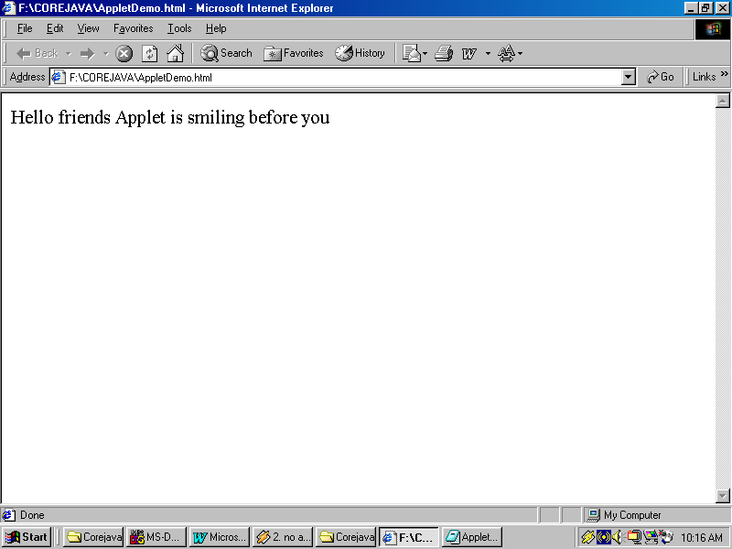

Applet LifeCycle:
1. public void init(): This method executes only once when applet downloads and excute in the browser. We provide all required resources for applet execution in init().
2. public void start(): It executes many times as and when the applet is displayed. Hence it is an ideal place to start the resources of the Applet.

3. public void paint(Graphics obj): This method is provided by container class. It executes the most. paint() paints the graphical information on the applet. Every time applet is raised, uncovered or maximized, restored paint executes.
4. public void stop(): When ever the applet goes out of the view stop() is executed and can be an ideal place to stop the animation threads or other resources that are not required when applet not in view. Applet may go out of view because applet is minimized or user moves to next page.
5. public void destroy(): It is last method and the final method to execute. It can be used to free the resources that are allocated to an applet.
//program that demonstrates the execution of life cycle functions of the Applet
import java.awt.*;
import java.applet.*;
public class applife extends Applet
{
String lc="";
public void init()
{
lc+="INIT";
repaint();
}
public void start()
{
lc+="START";
repaint();
}
public void paint(Graphics g)
{
lc+="PAINT";
g.drawString(lc,10,250);
}
public void stop()
{
lc+="STOP"; repaint(); }
public void destroy()
{
lc+="DESTROY";
repaint(); } } /*<applet code="applife" width="500" height="500">
</applet>*/
Output:
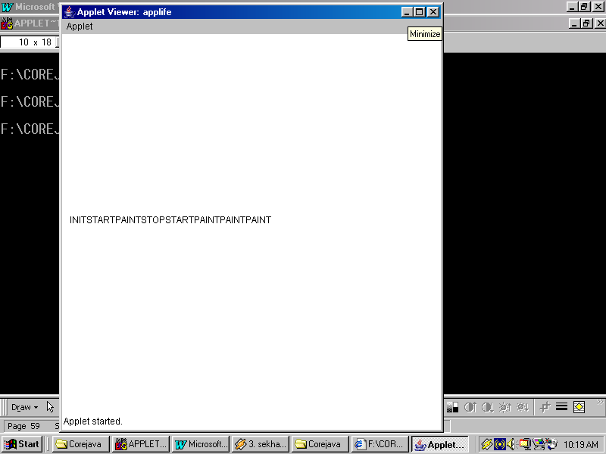
Java 2D Graphics Methods:
drawString(): Paints given String at the specified x & y co-ordinates on Applet.
Syntax: drawString(String, x-axis, y-axis);
DrawString(char[], x-axis, y-axis);
drawRect(): Draws rectangle and square shapes.
Sytax: drawString(int left, int top, int width, int height);
fillRect(): Same as drawRect() but fills with fore color or specified color given through setColor().
SetColor(colorconstant/Color Object):
Colorconstants can be Color.red, Color.blue, Color.green, Color.yellow, Color.gray, Color.lightGray, Color.pink, Color.black, Color.white, Color.magenta.
new Color(int redval, int greenval, int blueval);
drawOval(): Draws both ovals and circles.
Syntax: drawOval(int left, int top, int width, int height);
fillOval(): Same as drawOval but fills the shape with specified color.
drawPolygon(): Draws the polygon shape..
Syntax: drawPolygon(int x[], int y[], int no.of points);
fillPolygon(): Same as drawpolygon() but it fills the shape with the specified color.
drawArc(): Draws Arc shapes.
Syntax: drawArc(int left, int top, int width, int height, int startangle, int endangle);
fillArc(): same as drawArc() but fills the shape with the specified color.
drawLine(): Draws line between two specified points.
Syntax: drawLine(int x1, int y1, int x2, int y2);
//program that demonstrates the 2D Graphics methods of Java
import java.awt.*;
import java.applet.*;
public class appfig extends Applet
{
public void paint(Graphics g)
{
g.drawRect(10,10,80,80);
g.setColor(Color.pink);
g.fillRect(400,10,100,50);
g.drawOval(10,150,80,80);
g.setColor(Color.blue);
g.fillOval(400,150,100,60);
g.drawArc(10,300,80,80,0,180);
g.setColor(new Color(80,150,249));
g.fillArc(400,300,100,60,0,270);
} } /*<applet code="appfig" width="500" height="500">
</applet>*/
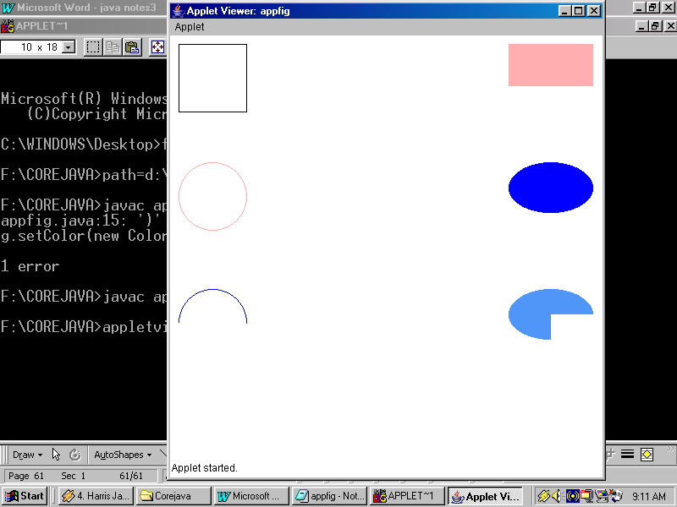
Output:

//program that displays polygon
import java.applet.*;
import java.awt.*;
public class polydemo extends Applet
{
int x[]={100,200,300,150,500};
int y[]={100,300,400,500,250};
public void paint(Graphics g)
{
g.setColor(Color.yellow);
g.fillPolygon(x,y,5);
}
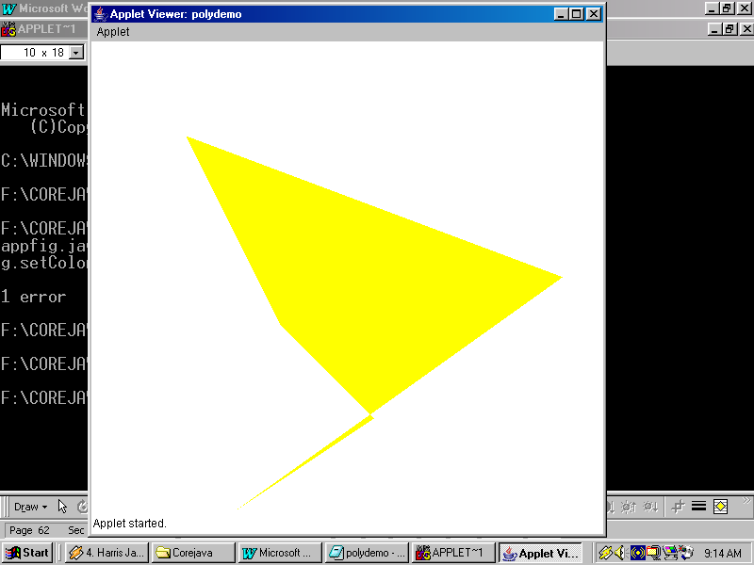
}
/*<applet code="polydemo" width="500" height="500">
</applet>*/

Output:

//program that demonstrates line animation
import java.applet.*;
import java.awt.*;
import java.util.*;
public class lineanimation extends Applet
{
Thread x;
Random r;
int randx=0;
int randy=0;
public void init()
{
x=new Thread(new Animator());
x.setDaemon(true);
r=new Random();
}
public void start()
{
x.start();
}
public void painter()
{
this.getGraphics().drawLine(250,250,randx,randy);
}
class Animator implements Runnable
{
public void run()
{
while(true)
{
try
{
randx=Math.abs(r.nextInt(500));
randy=Math.abs(r.nextInt(500));
painter();
x.sleep(200);
}catch(Exception e){}
}
}
}
}
/*<applet code="lineanimation" width="500" height="500">
</applet>*/

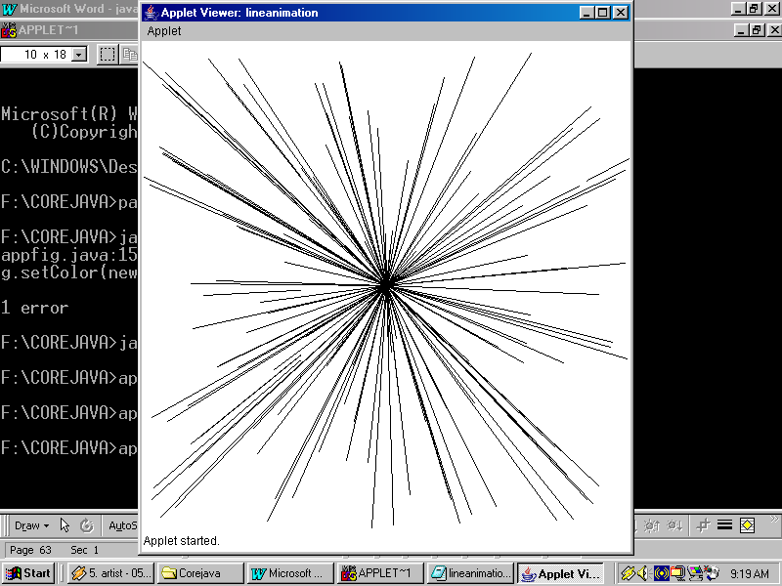
Output:
AWTComponents:

Abstract window toolkit, which provides all components like TextBoxes, buttons etc plus Frames and Dialogs. The components are

1.Label: This class creates Label control that displays non-editable information like titles, sub headings, captions etc. you cannot directly edit the text on label.

Constructors:

Label(): Creates blank label.

Label(String caption): Creates Label with text in it.

Label(String caption,int alignment-const): Creates Label with caption in specified alignment. Alignment constants can be:
Label.LEFT
Label.RIGHT
Label.CENTER

Methods:

setText(String caption): Assigns new caption to the lable.

String getText(): Returns the current caption of the Label.

2.TextField: Creates a textbox that allows you to input, edit or display data. TextField contains and return data in text format i.e. in String format.

Constructors:

TextField(): Creates blank textbox.

TextField(String defaultvalue): Creates textbox with default text in it.

TextField(int size): Creates a textbox a the specified size.

TextField(String defaulttext,int size)

Methods:

getText(), setText()

setEchoChar(char): This method sets masking character for the textbox to be used as password field.
3.Button: Creates push buttons (or) command buttons that can be used to click and execute a process.

Constructors:

Button(): Creates a blank button.
Button(String caption): Creates a button with a caption on it.

Methods:

setLabel(): To set caption on button.
getLabel(): to return caption on button.

4.List: This class is used to create list boxes, that allows us to display set of predefined values. We can select one value from the list of values.

Constructors:

List(): Creates a blank List box.
List(int no.of rows): List box with no.of rows to display.
List(int no.of rows, boolean multiselect): If the multiselect option is true then we can select two or more values at a time from the List box.

Methods:

String getSelectedItem(): Returns the currently selected item.
int getSelectedIndex(): Returns the index of the item selectd. First item is 0.
int getListCount(): Returns the total no.of items in the List box.
select(String item): Selects the specified item in the list box.
select(int itemIndex): Selects the item with given index.
addItem(String item): This method is used to add the given item to the List box.
String[] getSelectedItems(): This method returns the selected items into a String array in multi select List box.
int[] getSelectedIndexes(): This method returns the selected item indexes into an integer array in multi select List box.

5.Choice: Creates a Choice control (i.e. a pull down combo box). It is similar to List box except that it displays the items pulldown and multi select is not possible.

Constructors:

Choice(): Creates blank Choice control.

Methods:

String getSelectedItem();
int getSelectedIndex();
int getListCount();
select(String item);
select(String itemIndex);
addItem(String item);

6.Checkbox:

Used to create Checkbox control to represent a set of options from which one (or) more can be selected. Selected Checkbox displays a tick mark.

Constructors:

Checkbox(): Creates a blank Checkbox.
Checkbox(String caption,Boolean state): If the state is true the Checkbox is default selected.

7.RadioButton:

RadioButtons are created by using an overloaded constructor of Checkbox by passing CheckboxGroup object into Checkbox constructor.

Constructor:
Checkbox(String caption,CheckboxGroup obj,boolean state);

Methods:
boolean getState(): Returns true if Checkbox/ RadioButton is selected.
setState(boolean state): Changes the state of the Checkbox/Radiobutton.
8.ScrollBar: Creates Scrollbar that can be used to perform some process when scrolled.

Constructor:
Scrollbar(int orientation, int position, int pageincrement, int minimum, int maximum);

Orientation can be:

Scrollbar.VERTICAL
Scrollbar.HORIZONTAL

Methods:
int getValue(): Returns current value of Scrollbar.

setValue(int): Assigns the given value to Scrollbar.
setUnitIncrement(int value): Assigns the given value to Scrollbar as unit increment value.

int getUnitIncrement(): Returns the unit increment value of the Scrollbar.

setBlockIncrement(int value): Assigns the given value to Scrollbar as block increment.

int getBlockIncrement(): Returns the block increment value of the Scrollbar.

9.TextArea: Creates a multiline Textbox.

Constructor:
TextArea(int no.of rows, int no.of cols);

Methods:
setText()
getText()
append(String text): Adds new String at the end.

replace(String text, int startpos, int endpos): Replaces the existing text with the given text.

Event Model & Listeners:

All Listeners are interfaces. Applet behaves like a processor. It will be busy performing task assigned to it and will be temporally interrupted by an incoming call of event.

Event Model:

The event model prior to java1.1 was premitive type and is currently depricated. In the older event model all the components of the applet were able to generate events. This created lots of wastage of processing time because every time the event is generated the applet is interrupted , listen to the incoming event. If the event was generated by a component that is not interested in performing any process the event was delighted upwards to the super class, the event will propagated in the class hierarchy till it was processed or migrated out of the hierarchy due to this inherit defect a new model was introduced, called ‘Delegation Event Model ‘. In this model the events are handled by interfaces called Listeners. A component is interested in generating event must register itself with appropriate Listener by using the method.

CompObject.addXXXListener(this (or) classobject);

An unregistered component will not generate any event. When the event occurs the appropriate method is called i.e. process is delegated to required method and the method will handle the event.

The method have an event source class that encapsulates the objects that is causing the event. Using the getSource() of event source class you can retrieve the component responsible for event. When a component is no longer interested in generating events its Listener can be removed by using compObejct.removeXXXListener(this (or) classobj).
Steps to handle components:

- Create handlers before init().
- Instantiate them in init().
- If required add appropriate Listener using compObj.addXXXListener().
- To display the components add them to applet using the method add(compObject).
- Implement the methods of Listener.

Listeners:

1.ActionListener: It is used to preocess click events like button click, menu click etc. Its method is

public void actionPerformed(ActionEvent var);
2.MouseListener: It is used to deal with mouse operations like mouse enter, exit etc.

Methods:

public void mouseEntered(MouseEvent var)
public void mouseExited(MouseEvent var)
public void mousePressed(MouseEvent var)
public void mouseReleased(MouseEvent var)
public void mouseClicked(MouseEvent var)

3.MouseMotionListener: It is also used to deal with mouse operations but is restricted to mouse movement and dragging.

Methods:

public void mouseMoved(MouseEvent var)
public void mouseDragged(MouseEvent var)

//program that demonstrates ActionListener
import java.applet.*;
import java.awt.*;
import java.awt.event.*;
public class appcalc extends Applet implements ActionListener
{
TextField t1,t2,t3;
Button addr,subt,mult,divd;
public void init()
{
t1=new TextField(20);
t2=new TextField(20);
t3=new TextField(20);
addr=new Button("+");
subt=new Button("-");
mult=new Button("*");
divd=new Button("/");
addr.addActionListener(this);
subt.addActionListener(this);
mult.addActionListener(this);
divd.addActionListener(this);
add(new Label("Enter no.1"));
add(t1);
add(new Label("Enter no.2"));
add(t2);
add(new Label("Result"));
add(t3);
add(addr);add(subt);add(mult);add(divd);
}
public void actionPerformed(ActionEvent ae)
{
double a,b,c;
a=Double.parseDouble(t1.getText());
b=Double.parseDouble(t2.getText());
if(ae.getSource()==addr)
{
c=a+b;
}
else if(ae.getSource()==subt)
{
c=a-b;
}
else if(ae.getSource()==mult)
{
c=a*b;
}
else
{
c=a/b;
}
t3.setText(Double.toString(c));
}
}
/*<applet code="appcalc" width="500" height="500">
</applet>*/
Output:
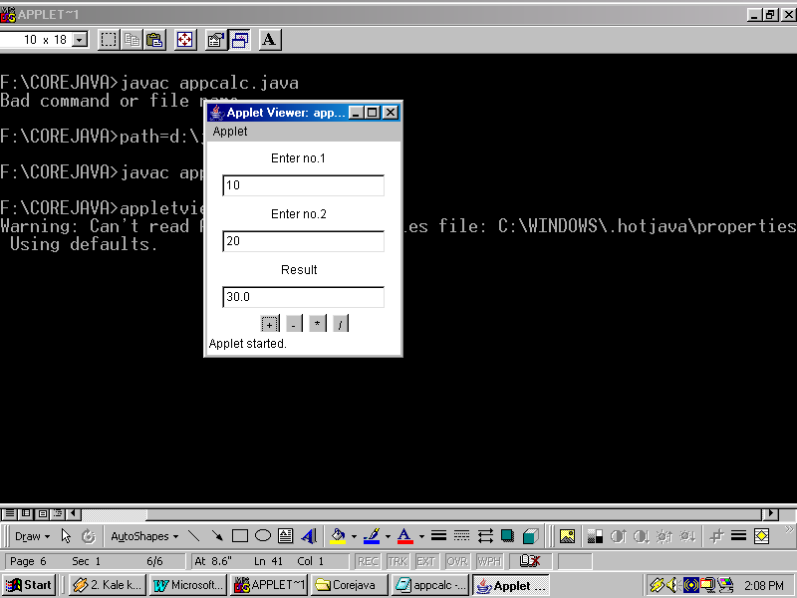
//program that demonstrates MouseListener
import java.applet.*;
import java.awt.*;
import java.awt.event.*;
public class appml extends Applet implements MouseListener
{
Button b1;
public void init()
{
b1=new Button("Hello");
b1.setBackground(Color.pink);
b1.addMouseListener(this);
add(b1);
}
public void mouseEntered(MouseEvent me)
{
b1.setBackground(Color.green);
}
public void mouseExited(MouseEvent me)
{
b1.setBackground(Color.blue);
}
public void mousePressed(MouseEvent me)
{
b1.setBackground(Color.lightGray);
}
public void mouseReleased(MouseEvent me)
{
b1.setBackground(Color.yellow); }
public void mouseClicked(MouseEvent me)
{}
} /*<applet code="appml" width="500" height="500">
</applet>*/
Output:

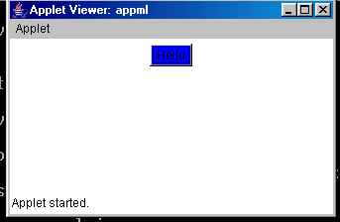
//program that demonstrates MouseMotionListener
import java.applet.*;
import java.awt.*;
import java.awt.event.*;
public class appmml extends Applet implements MouseMotionListener
{
public void init()
{
addMouseMotionListener(this);
}
public void mouseMoved(MouseEvent me)
{}
public void mouseDragged(MouseEvent me)
{
int x,y;
x=me.getX();
y=me.getY();
this.getGraphics().fillOval(x,y,3,3);
} }
/*<applet code="appmml" width="500" height="500">
</applet>*/

Output:
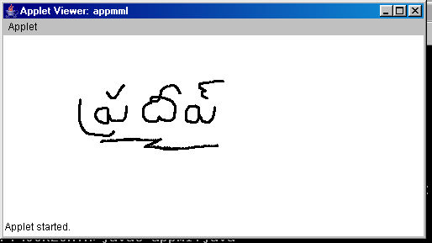

4.FocusListener: It executes when the components loses or gains the cursor.

Methods:

public void focusGained(FocusEvent var);
public void focusLost(FocusEvent var);

5.ItemListener: This Listener is used for components like Checkboxes, Radiobuttons, Choice controls and List control. When the selection state of the component change its, method executed.

Method:

public void itemStateChanged(ItemEvent var);

6.TextListener: This Listener is used with TextFields. It is used to execute the code whenever the content of TextField is changed.

Methods:

public void textValueChanged(TextEvent var);

//program that demonstrates FocusListener
import java.applet.*;
import java.awt.*;
import java.awt.event.*;
public class appfl extends Applet implements FocusListener
{
TextField ename,basic,hra,da,pf,net;
public void init()
{
ename=new TextField(20);
basic=new TextField(20);
hra=new TextField(20);
da=new TextField(20);
pf=new TextField(20);
net=new TextField(20);
ename.addFocusListener(this);
basic.addFocusListener(this);
add(new Label("Employee name"));
add(ename);
add(new Label("Basic salary"));
add(basic);
add(new Label("HRA"));
add(hra);
add(new Label("DA"));
add(da);
add(new Label("PF"));
add(pf);
add(new Label("Net salary"));
add(net);
hra.setEditable(false);
da.setEditable(false);
pf.setEditable(false);
net.setEditable(false);
}
public void focusLost(FocusEvent fe)
{
if(fe.getSource()==basic)
{
double bas,hr,d,p,nt;
bas=Double.parseDouble(basic.getText());
hr=bas*20/100;
d=bas*10/100;
p=bas*8/100;
nt=(bas+hr+d)-p;
hra.setText(Double.toString(hr));
da.setText(Double.toString(d));
pf.setText(Double.toString(p));
net.setText(Double.toString(nt));
}
}
public void focusGained(FocusEvent fe)
{
if(fe.getSource()==ename)
{
ename.setText("");
basic.setText("");
hra.setText("");
da.setText("");
pf.setText("");
net.setText("");
}
}
}
/*<applet code="appfl" width="500" height="500">
</applet>*/
Output:

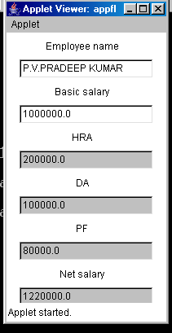
//program that demonstrates FocusListener and TextListener
import java.applet.*;
import java.awt.*;
import java.awt.event.*;
public class apptl extends Applet implements FocusListener,TextListener
{
TextField ename,basic,hra,da,pf,net;
public void init()
{
ename=new TextField(20);
basic=new TextField(20);
hra=new TextField(20);
da=new TextField(20);
pf=new TextField(20);
net=new TextField(20);
ename.addFocusListener(this);
basic.addTextListener(this);
add(new Label("Employee name"));
add(ename);
add(new Label("Basic salary"));
add(basic);
add(new Label("HRA"));
add(hra);
add(new Label("DA"));
add(da);
add(new Label("PF"));
add(pf);
add(new Label("Net salary"));
add(net);
hra.setEditable(false);
da.setEditable(false);
pf.setEditable(false);
net.setEditable(false);
}
public void focusLost(FocusEvent fe)
{}
public void focusGained(FocusEvent fe)
{
ename.setText("");
basic.setText("");
hra.setText("");
da.setText("");
pf.setText("");
net.setText("");
}
public void textValueChanged(TextEvent te)
{
double bas,hr,d,p,nt;
bas=Double.parseDouble(basic.getText());
hr=bas*20/100;
d=bas*10/100;
p=bas*8/100;
nt=(bas+hr+d)-p;
hra.setText(Double.toString(hr));
da.setText(Double.toString(d));
pf.setText(Double.toString(p));
net.setText(Double.toString(nt));
} } /*<applet code="apptl" width="500" height="500">
</applet>*/

Output:

//program that demonstrates ItemListener
import java.applet.*;
import java.awt.*;
import java.awt.event.*;
public class appil extends Applet implements ItemListener
{
Choice country,capital;
public void init()
{
country=new Choice();
capital=new Choice();
country.addItem("India");
country.addItem("Srilanka");
country.addItem("Bangladesh");
country.addItem("Napel");
country.addItem("Pakistan");
capital.addItem("Delhi");
capital.addItem("Colombo");
capital.addItem("Dakha");
capital.addItem("Katmandu");
capital.addItem("Islamabad");
country.addItemListener(this);
add(country);
add(capital);
}
public void itemStateChanged(ItemEvent ie)
{
int index=country.getSelectedIndex();
capital.select(index);
}
}
/*<applet code="appil" width="500" height="500">
</applet>*/

Output:

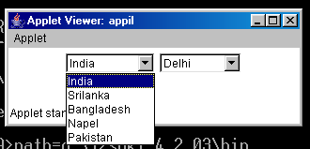
7.KeyListener: It is used in association with keyboard whenever key is typed on the keyboard it executes 3 methods.

Methods:

public void keyPressed(KeyEvent var);
public void keyReleased(KeyEvent var);
public void keyTyped(KeyEvent var);

8.ComponentListener: This is used with containers to respond to operations like moving the component adding (or) removing the component etc.

Methods:

public void componentResized(ComponentEvent var);
public void componentMoved(ComponentEvent var);
public void componentShown(ComponentEvent var);
public void componentHidden(ComponentEvent var);

9.ContainerListenr: It is also used with container to respond to operations like adding (or) removing components.

Methods:
public void componentAdded(ContainerEvent var);
public void componentRemoved(ContainerEvent var);
10.AdjustmentListener: We use this Listener with Scrollbars. Executes its method whenever the Scrollbar is scrolled.

Methods:

public void adjustmentValueChanged(AdjustmentEvent var);

//program that demonstrates AdjustmentListener
import java.applet.*;
import java.awt.*;
import java.awt.event.*;
public class appal extends Applet implements AdjustmentListener
{
Label red,green,blue;
Scrollbar rbar,gbar,bbar;
public void init()
{
red=new Label();
green=new Label();
blue=new Label();
rbar=new Scrollbar(Scrollbar.HORIZONTAL,0,10,0,255);
gbar=new Scrollbar(Scrollbar.HORIZONTAL,0,10,0,255);
bbar=new Scrollbar(Scrollbar.HORIZONTAL,0,10,0,255);
rbar.addAdjustmentListener(this);
gbar.addAdjustmentListener(this);
bbar.addAdjustmentListener(this);
setLayout(null);
add(red).setBounds(50,100,50,30);
add(rbar).setBounds(150,100,150,30);
add(green).setBounds(50,200,50,30);
add(gbar).setBounds(150,200,150,30);
add(blue).setBounds(50,350,50,30);
add(bbar).setBounds(150,350,150,30);
}
public void adjustmentValueChanged(AdjustmentEvent al)
{
if(al.getSource()==rbar)
{
red.setBackground(new Color(rbar.getValue(),0,0));
}
else if(al.getSource()==gbar)
{
green.setBackground(new Color(0,gbar.getValue(),0));
}
else
{
blue.setBackground(new Color(0,0,bbar.getValue()));
} } }
/*<applet code="appal" width="500" height="500">
</applet>*/

Output:
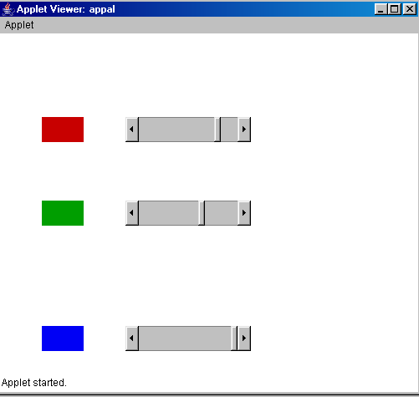
10.WindowListener: WindowListener works only on containers like Frames and Dialogs but it won’t works on Applets. Window Listener is used to perform the window operations.

Methods:

Public void windowOpened(WindowEvent var);
Public void windowOpening(WindowEvent var);
Public void windowActivated(WindowEvent var);
Public void windowDeactivated(WindowEvent var);
Public void windowIconified(WindowEvent var);
Public void windowDeiconified(WindowEvent var);
Public void windowClosing(WindowEvent var);
Public void windowClosed(WindowEvent var);

Frame:

Frame is standalone window. It can have toolbars and Menus. Bydefault Frames has BorderLayout. Bydefault Applet has FlowLayout.

A Frame is standalone window that sets on desktop like the conventional window of Microsoft Windows operating system. Begin a standalone window a frame can have toolbars, menubars, popups etc.

Unlike Applet frame has no security restrictions and is liable to read (or) write to disk, access IPaddress etc. like a conventional application program Frame can have main().

Bydefault, Frame is not visible and to display use setVisible(true), even it has no dimensions bydefault, to specify its dimensions use setSize(int width,int height)

Constructors:

Frame();
Frame(String tilte);

//program that demonstrates Frame and WindowListener
import java.awt.*;
import java.awt.event.*;
public class frameex extends Frame implements WindowListener
{
frameex()
{
super("My Frame");
addWindowListener(this);
setVisible(true);
setSize(300,400);
}
public static void main(String args[])
{
new frameex();
}
public void windowClosing(WindowEvent we)
{
System.exit(0);
}
public void windowClosed(WindowEvent we)
{}
public void windowOpened(WindowEvent we)
{}
public void windowOpening(WindowEvent we)
{}
public void windowActivated(WindowEvent we)
{}
public void windowDeactivated(WindowEvent we)
{}
public void windowIconified(WindowEvent we)
{}
public void windowDeiconified(WindowEvent we)
{}
}

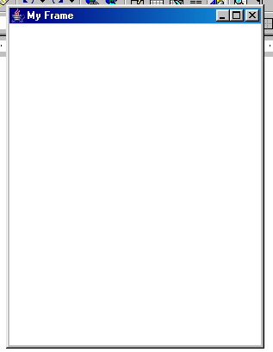
Output:

Layout Managers:

1.FlowLayout
2.GridLayout
3.BorderLayout
4.CardLayout
5.GridLayout

These core classes that arrange the components in the specified Layout format. Though you can manually arrange the components by canceling the Layout manager using setBounds(). But it is difficult process and lengthen the code. Apart from this each O/S has its own dimensions for components, consequently when setBounds() violates these dimensions Exceptions may arise and hence it is always responsible to allow Layout managers to arrange components rather than manually arrange.
FlowLayout:

It arranges the components one next to another and when right most part is reached the component will automatically roll down to next row.

Constructors:

FlowLayout();
FlowLayout(int Alignment);
FlowLayout(int Alignment, int Hgap, int Vgap);

Alignment can be FlowLayout.LEFT, FlowLayout.RIGHT, FlowLayout.CENTER

//program that demonstrates FlowLayout
import java.applet.*;
import java.awt.*;
public class flowdemo extends Applet
{
public void init()
{
setLayout(new FlowLayout(FlowLayout.CENTER,5,5));
for(int i=1;i<=200;i++)
add(new Button("Button"+i));
}
}
/*<applet code="flowdemo" width="500" height="500">
</applet>*/

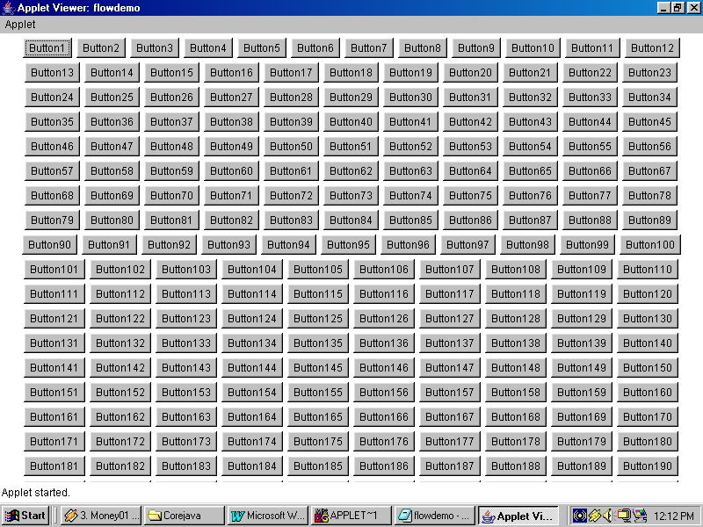
Output:
GridLayout:

Divides the container into no.of rows and columns, resulting in cells. Each cell can hold a component.

Constructors:
GridLayout(int rows,int cols);
GridLayout(int rows,int cols,int Hgap,int Vgap);
//program that demonstrates GridLayout
import java.applet.*;
import java.awt.*;
public class griddemo extends Applet
{
public void init()
{
setLayout(new GridLayout(25,8));
for(int i=1;i<=200;i++)
add(new Button("Button"+i));
}
}
/*<applet code="griddemo" width="500" height="500">
</applet>*/

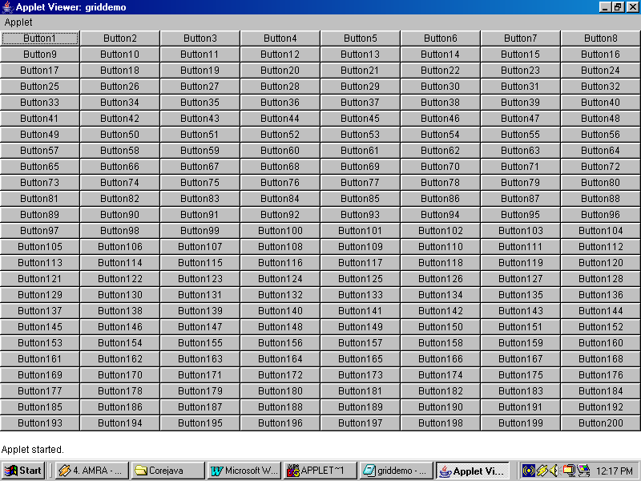
Output:

BorderLayout: It divides the container into 5 zones namely 1)East 2)North 3)South 4)West 5)Center. Per direction only one component can be added if you want to add multiple components use Panel and to that Panel you add method is specified as
Add(CompObj,Direction).

Directions can be “East”,’North”,”South”,”West”,”Center”.

//program that demonstrates BorderLayout
import java.applet.*;
import java.awt.*;
public class borderdemo extends Applet
{
public void init()
{
setLayout(new BorderLayout());
add(new Button("East"),"East");
add(new Button("West"),"West");
add(new Button("North"),"North");
add(new Button("South"),"South");
add(new TextArea(24,80),"Center");
}
}
/*<applet code="borderdemo" width="500" height="500">
</applet>*/

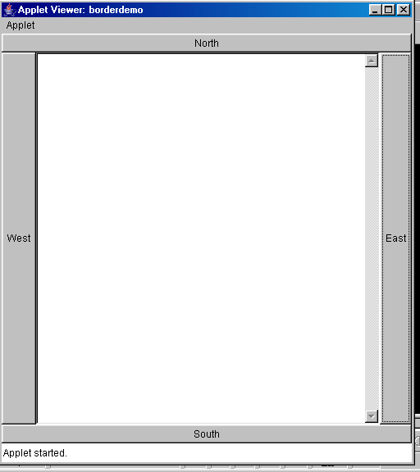
Output:
Panel: Panel is also one of the containers like Applet, Frame and Dialog. It can hold components. But it is not an individual container like Applet or Frame. Hence it must be nested within another Container.

Constructor:
Panel();
//program that demonstrates Panel
import java.applet.*;
import java.awt.*;
import java.awt.event.*;
public class paneldemo extends Applet
{
public void init()
{
Panel p1=new Panel();
Panel p2=new Panel();
Panel p3=new Panel();
setLayout(new GridLayout(1,3));
p1.setLayout(new FlowLayout());
p2.setLayout(new GridLayout(10,5));
p3.setLayout(new BorderLayout());
for(int i=1;i<=100;i++)
p1.add(new Button("Button"+i));
for(int i=1;i<=100;i++)
p2.add(new Button("Button"+i));
p3.add(new Button("East"),"East");
p3.add(new Button("West"),"West");
p3.add(new Button("North"),"North");
p3.add(new Button("South"),"South");
p3.add(new TextArea(24,80),"Center");
add(p1);add(p2);add(p3);
}
}
/*<applet code="paneldemo" width="500" height="500">
</applet>*/

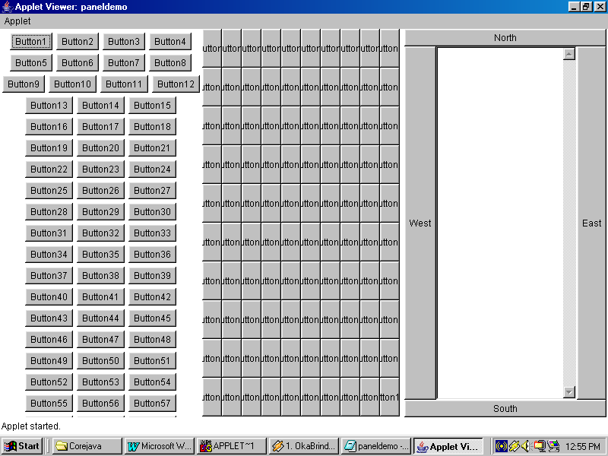
Output:

Menus:

Menus
File Edit View
New
Open
Save
SaveAs
Print
Exit

MenuBar

MenuItem

Applets cannot contain Menu. But Frames and Dialogs can contain Menus because they are standalone windows. Menu can be created by using a collection of 3 classes.

1.MenuBar: This class creates a blank menu bar without any menu objects on it. It can be attached to the Frame using the method setMenuBar(menubarObj).
2.Menu: This class is used to create the top level menus like File, Edit, Insert etc. both MenuBar and Menu are passive and cannot respond to events.
3.MenuItem: This objects of this class constitutes sublevel menus like New, Open, Save etc. inside file menu. It can implement ActionListener, thus can respond to clicks.

Steps to create Menu are:
- Create MenuBar Object.
- Create Menu Objects.
- Create MenuItem Objects.
- Implement appropriate Listener.
- Add MenuItems to Menus, Menus to MenuBar and set MenuBar to Frame.

FileDialog: This class is used to create file dialog boxes that allow opening of file or saving file. Infact they can return you the folder and the file name that was selected in it. Whereas the IOStreams will handle reading or writing of files.

Constructors:

FileDialog(parentFrameobj, String title);
FileDialog(parentFrameobj, String title, int type);

Type can be FileDialog.LOAD, FileDialog.SAVE

Methods:

String getDirectory(): Returns the name of the folder selected by the FileDirectory.
String getFile(): Returns the name of the File, selected in the file dialog.

//program that demonstrates Menus
import java.awt.*;
import java.awt.event.*;
import java.io.*;
import java.applet.*;
public class mynotepad extends Frame implements ActionListener
{
MenuBar mbar;
Menu mnufile,mnuedit;
MenuItem mnufilenew,mnufileopen,mnufilesave,mnufileexit;
MenuItem mnueditcut,mnueditcopy,mnueditpaste;
FileDialog fdlg;
TextArea doc;
mynotepad()
{
super("My Notepad");
mbar=new MenuBar();
mnufile=new Menu("File");
mnuedit=new Menu("Edit");
mnufilenew=new MenuItem("New");
mnufileopen=new MenuItem("Open");
mnufilesave=new MenuItem("Save");
mnufileexit=new MenuItem("Exit");
mnueditcut=new MenuItem("Cut");
mnueditcopy=new MenuItem("Copy");
mnueditpaste=new MenuItem("Paste");
doc=new TextArea(24,80);
mnufile.add(mnufilenew);
mnufile.add(mnufileopen);
mnufile.add(mnufilesave);
mnufile.add(new MenuItem("-"));
mnufile.add(mnufileexit);
mnuedit.add(mnueditcut);
mnuedit.add(mnueditcopy);
mnuedit.add(mnueditpaste);
mbar.add(mnufile);
mbar.add(mnuedit);
mnufileopen.addActionListener(this);
mnufilesave.addActionListener(this);
mnufileexit.addActionListener(this);
add(doc,"Center");
setMenuBar(mbar);
setSize(600,600);
setVisible(true);
}
public void actionPerformed(ActionEvent ae)
{
try
{
if(ae.getSource()==mnufileexit)
{
System.exit(0);
}
else if(ae.getSource()==mnufileopen)
{
fdlg=new FileDialog(this,"File Open",FileDialog.LOAD);
fdlg.setVisible(true);
String s=fdlg.getDirectory()+"/"+fdlg.getFile();
FileInputStream fin=new FileInputStream(s);
String text="";
while(true)
{
int data=fin.read();
if(data==-1)
{
doc.setText(text);
fin.close();
break;
}
text+=((char)data)+"";
}
}
else
{
fdlg=new FileDialog(this,"File Save",FileDialog.SAVE);
fdlg.setVisible(true);
String s=fdlg.getDirectory()+"/"+fdlg.getFile();
FileOutputStream fout=new FileOutputStream(s);
String text=doc.getText();
byte b[]=text.getBytes();
for(int i=0;i<b.length;i++)
{
fout.write(b[i]);
}
}
}catch(Exception e){}
}
public static void main(String args[])
{
new mynotepad();
}
}

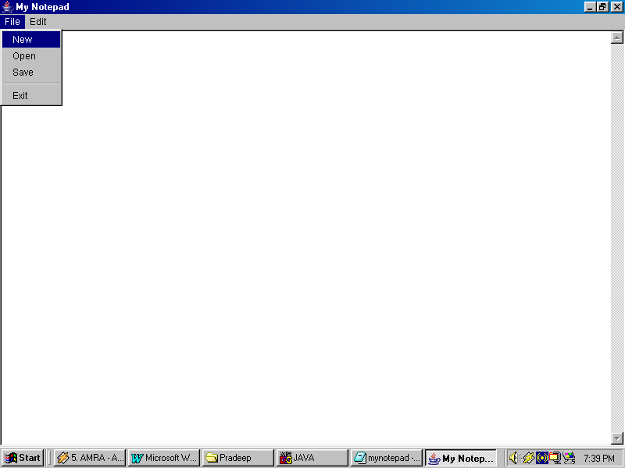
Output:
NetWorking:

Network is an interconnection between two or more systems to exchange information.

Advatages:
- By using network we can exchange information.
- By using network we can share resources.
- By using network we can reduce the cost of the infrastructure.

Types of Computer Networks: There are 3 types computer networks. They are:

1)LAN: If the systems within a room or within a building are connected with a network then that network is called LAN.

2)MAN: If the systems within a city or within a metropolitan area are connected with a network then that network is called MAN.

3)WAN: If the geographically separated systems are connected with a network then that network is called WAN.

Communication Media:

Communication media is a media through which we can communicate systems within a network. They are two types:
- Guided Media
- Unguided Media

Guided Media: If there exist a physical connection between the systems in a network then that communication media is called Guided media.

Unguided Media: If there is no physical connection between the systems in a network then that communication media is called Unguided media.

Protocol: A protocol is a set of rules that governs the data communication in a network.

IPAddress: IPAddress is an unique identity of the system within the network. There are two types of IPAddresses are available. They are: V4 and V6.

TCP/IP:

TCP/IP stands for Transmission Control Protocol/Internet Protocol. It is a high reliable, persistence, Bi-directional and point to point protocol. If we send any information by using TCP/IP then information will surely reach to the destination system under any circumstances.

TCP/IP maintains a persistent connection between the systems until any one of the system want to disconnect.

Socket is an abstraction that is used either to send or receive the information. Java provides two types of TCP/IP sockets. They are:

- ServerSocket
- Socket

ServerSocket acts as a server that provides services and Socket acts as a client that uses the services of the server. ServerSocket runs on a system with unique IPAddress and provides services through a virtual channel called port. Hence a single system can provides different services on different port number.

ServerSocket is a passive program that runs alone. Whereas Socket needs atleast one ServerSocket.

ServerSocket:

Constructors:

ServerSocket(int portno);
ServerSocket(int portno, int maxqueue);

Where maxqueue represents, the no.of clients can connect to this ServerSocket at a time.

Methods:

Socket accept(): This method returns Socket object to the client whenever a client connects this ServerSocket

getOutputStream(): By using this method we can send information.

getInputStream(): by using this method we can receive information. Both these methods causes IOException.

Socket:

Construtors:

Socket(String IPAddress, int portno);
Socket(String DNS, int portno);

Methods:

getOutputStream();
getInputStream();

//program that demonstrates ServerSocket
import java.net.*;
import java.io.*;
public class ssocket
{
public static void main(String args[]) throws Exception
{
ServerSocket ss=new ServerSocket(9999);
System.out.println("Server is created");
System.out.println("Waiting for a client to connect");
Socket s=ss.accept();
System.out.println("1 client connected");
}
}

//program that demonstrates Socket
import java.net.*;
import java.io.*;
public class socket
{
public static void main(String args[]) throws Exception
{
Socket s=new Socket("bits",9999);
System.out.println(" client is created and connected to server");
}
}

//program that demonstrates sending message from ServerSocket
import java.net.*;
import java.io.*;
public class ssocket
{
public static void main(String args[]) throws Exception
{
ServerSocket ss=new ServerSocket(9999);
System.out.println("Server is created");
System.out.println("Waiting for a client to connect");
Socket s=ss.accept();
System.out.println("1 client connected");
PrintStream out=new PrintStream(s.getOutputStream());
out.println("This is server side message");
}
}
//program that demonstrates receiving message from SocketSocket to Socket
import java.net.*;
import java.io.*;
public class socket
{
public static void main(String args[]) throws Exception
{
Socket s=new Socket("bits",9999);
System.out.println(" client is created and connected to server");
DataInputStream dis=new DataInputStream(s.getInputStream());
System.out.println(dis.readLine());
}
}

URL & URLConnection:

URL: URL is a class which is used to connect remote servers. URL stands for Uniform Resource Locator. URL class consists of the following constructors. All constructors throws MalformedURLException.

Constructors:

URL(String url);
URL(String protocol, String host, String portno, String path);
URL(String protocol, String host, String path);

Methods:

String getProtocol();
String getHost();
String getPort();
String getFile();
URLConnection openConnection();

URLConnection: A network class which is used to obtain the attributes of a Remoteserver. openConnection() of URL class returns object of this class.

Methods:

long getDate();
long getLastModified();
String getContentType();
int getContentLength();
InputStream getInputStream();

//program that demonstrates URL & URLConnection
import java.net.*;
import java.io.*;
import java.util.*;
public class urldemo
{
public static void main(String args[]) throws Exception
{
URL url=new URL("http://in.rediff.com/index.html");
System.out.println("Protocol:"+url.getProtocol());
System.out.println("Host:"+url.getHost());
System.out.println("File:"+url.getFile());
URLConnection urlcon=url.openConnection();
System.out.println("Date:"+new Date(urlcon.getDate()));
System.out.println("Last modified date:"+new Date(urlcon.getLastModified()));
System.out.println("Content length:"+urlcon.getContentLength());
System.out.println("Content Type:"+urlcon.getContentType());
InputStream input=urlcon.getInputStream();
FileOutputStream fout=new FileOutputStream("index.html");
while(true)
{
int data=input.read();
if(data==-1)
{
fout.close();
input.close();
break;
}
fout.write(data);
}
}
}

